Chapter 09
Net Present Value and Other Investment Criteria

Multiple Choice Questions
1. A project has an initial cost of $27,400 and a market value of $32,600. What is the difference between these two values called?
A. net present value
B. internal return
C. payback value
D. profitability index
E. discounted payback

2. Which one of the following methods of project analysis is defined as computing the value of a project based upon the present value of the project's anticipated cash flows?
A. constant dividend growth model
B. discounted cash flow valuation
C. average accounting return
D. expected earnings model
E. internal rate of return

3. The length of time a firm must wait to recoup the money it has invested in a project is called the:
A. internal return period.
B. payback period.
C. profitability period.
D. discounted cash period.
E. valuation period.

4. The length of time a firm must wait to recoup, in present value terms, the money it has in invested in a project is referred to as the:
A. net present value period.
B. internal return period.
C. payback period.
D. discounted profitability period.
E. discounted payback period.

5. A project's average net income divided by its average book value is referred to as the project's average:
A. net present value.
B. internal rate of return.
C. accounting return.
D. profitability index.
E. payback period.

6. The internal rate of return is defined as the:
A. maximum rate of return a firm expects to earn on a project.
B. rate of return a project will generate if the project in financed solely with internal funds.
C. discount rate that equates the net cash inflows of a project to zero.
D. discount rate which causes the net present value of a project to equal zero.
E. discount rate that causes the profitability index for a project to equal zero.

7. You are viewing a graph that plots the NPVs of a project to various discount rates that could be applied to the project's cash flows. What is the name given to this graph?
A. project tract
B. projected risk profile
C. NPV profile
D. NPV route
E. present value sequence

8. There are two distinct discount rates at which a particular project will have a zero net present value. In this situation, the project is said to:
A. have two net present value profiles.
B. have operational ambiguity.
C. create a mutually exclusive investment decision.
D. produce multiple economies of scale.
E. have multiple rates of return.

9. If a firm accepts Project A it will not be feasible to also accept Project B because both projects would require the simultaneous and exclusive use of the same piece of machinery. These projects are considered to be:
A. independent.
B. interdependent.
C. mutually exclusive.
D. economically scaled.
E. operationally distinct.

10. The present value of an investment's future cash flows divided by the initial cost of the investment is called the:
A. net present value.
B. internal rate of return.
C. average accounting return.
D. profitability index.
E. profile period.

11. A project has a net present value of zero. Which one of the following best describes this project?
A. The project has a zero percent rate of return.
B. The project requires no initial cash investment.
C. The project has no cash flows.
D. The summation of all of the project's cash flows is zero.
E. The project's cash inflows equal its cash outflows in current dollar terms.

12. Which one of the following will decrease the net present value of a project?
A. increasing the value of each of the project's discounted cash inflows
B. moving each of the cash inflows back to a later time period
C. decreasing the required discount rate
D. increasing the project's initial cost at time zero
E. increasing the amount of the final cash inflow

13. Which one of the following methods determines the amount of the change a proposed project will have on the value of a firm?
A. net present value
B. discounted payback
C. internal rate of return
D. profitability index
E. payback

14. If a project has a net present value equal to zero, then:
A. the total of the cash inflows must equal the initial cost of the project.
B. the project earns a return exactly equal to the discount rate.
C. a decrease in the project's initial cost will cause the project to have a negative NPV.
D. any delay in receiving the projected cash inflows will cause the project to have a positive NPV.
E. the project's PI must be also be equal to zero.

15. Rossiter Restaurants is analyzing a project that requires $180,000 of fixed assets. When the project ends, those assets are expected to have an aftertax salvage value of $45,000. How is the $45,000 salvage value handled when computing the net present value of the project?
A. reduction in the cash outflow at time zero
B. cash inflow in the final year of the project
C. cash inflow for the year following the final year of the project
D. cash inflow prorated over the life of the project
E. not included in the net present value

16. Which one of the following increases the net present value of a project?
A. an increase in the required rate of return
B. an increase in the initial capital requirement
C. a deferment of some cash inflows until a later year
D. an increase in the aftertax salvage value of the fixed assets
E. a reduction in the final cash inflow

17. Net present value:
A. is the best method of analyzing mutually exclusive projects.
B. is less useful than the internal rate of return when comparing different sized projects.
C. is the easiest method of evaluation for non-financial managers to use.
D. is less useful than the profitability index when comparing mutually exclusive projects.
E. is very similar in its methodology to the average accounting return.

18. Which one of the following is a project acceptance indicator given an independent project with investing type cash flows?
A. profitability index less than 1.0
B. project's internal rate of return less than the required return
C. discounted payback period greater than requirement
D. average accounting return that is less than the internal rate of return
E. modified internal rate of return that exceeds the required return

19. Why is payback often used as the sole method of analyzing a proposed small project?
A. Payback considers the time value of money.
B. All relevant cash flows are included in the payback analysis.
C. It is the only method where the benefits of the analysis outweigh the costs of that analysis.
D. Payback is the most desirable of the various financial methods of analysis.
E. Payback is focused on the long-term impact of a project.

20. Which of the following are advantages of the payback method of project analysis?
I. works well for research and development projects
II. liquidity bias
III. ease of use
IV. arbitrary cutoff point
A. I and II only
B. I and III only
C. II and III only
D. II and IV only
E. II, III, and IV only

21. Samuelson Electronics has a required payback period of three years for all of its projects. Currently, the firm is analyzing two independent projects. Project A has an expected payback period of 2.8 years and a net present value of $6,800. Project B has an expected payback period of 3.1 years with a net present value of $28,400. Which projects should be accepted based on the payback decision rule?
A. Project A only
B. Project B only
C. Both A and B
D. Neither A nor B
E. Answer cannot be determined based on the information given.

22. A project has a required payback period of three years. Which one of the following statements is correct concerning the payback analysis of this project?
A. The cash flows in each of the three years must exceed one-third of the project's initial cost if the project is to be accepted.
B. The cash flow in year three is ignored.
C. The project's cash flow in year three is discounted by a factor of (1 + R)³.
D. The cash flow in year two is valued just as highly as the cash flow in year one.
E. The project is acceptable whenever the payback period exceeds three years.

23. A project has a discounted payback period that is equal to the required payback period. Given this, which of the following statements must be true?
I. The project must also be acceptable under the payback rule.
II. The project must have a profitability index that is equal to or greater than 1.0.
III. The project must have a zero net present value.
IV. The project's internal rate of return must equal the required return.
A. I only
B. I and II only
C. II and III only
D. I, III, and IV only
E. I, II, III, and IV

24. Which one of the following statements related to payback and discounted payback is correct?
A. Payback is a better method of analysis than is discounted payback.
B. Discounted payback is used more frequently in business than is payback.
C. Discounted payback does not require a cutoff point like the payback method does.
D. Discounted payback is biased towards long-term projects while payback is biased towards short-term projects.
E. Payback is used more frequently even though discounted payback is a better method.

25. Applying the discounted payback decision rule to all projects may cause:
A. some positive net present value projects to be rejected.
B. the most liquid projects to be rejected in favor of the less liquid projects.
C. projects to be incorrectly accepted due to ignoring the time value of money.
D. a firm to become more long-term focused.
E. some projects to be accepted which would otherwise be rejected under the payback rule.

26. Which one of the following correctly applies to the average accounting rate of return?
A. It considers the time value of money.
B. It measures net income as a percentage of the sales generated by a project.
C. It is the best method of analyzing mutually exclusive projects from a financial point of view.
D. It is the primary methodology used in analyzing independent projects.
E. It can be compared to the return on assets ratio.

27. Which one of the following is an advantage of the average accounting return method of analysis?
A. easy availability of information needed for the computation
B. inclusion of time value of money considerations
C. the use of a cutoff rate as a benchmark
D. the use of pre-tax income in the computation
E. use of real, versus nominal, average income

28. Which of the following are considered weaknesses in the average accounting return method of project analysis?
I. exclusion of time value of money considerations
II. need of a cutoff rate
III. easily obtainable information for computation
IV. based on accounting values
A. I only
B. I and IV only
C. II and III only
D. I, II, and IV only
E. I, II, III, and IV

29. Which one of the following statements related to the internal rate of return (IRR) is correct?
A. The IRR yields the same accept and reject decisions as the net present value method given mutually exclusive projects.
B. A project with an IRR equal to the required return would reduce the value of a firm if accepted.
C. The IRR is equal to the required return when the net present value is equal to zero.
D. Financing type projects should be accepted if the IRR exceeds the required return.
E. The average accounting return is a better method of analysis than the IRR from a financial point of view.

30. The internal rate of return:
A. may produce multiple rates of return when cash flows are conventional.
B. is best used when comparing mutually exclusive projects.
C. is rarely used in the business world today.
D. is principally used to evaluate small dollar projects.
E. is easy to understand.

31. Tedder Mining has analyzed a proposed expansion project and determined that the internal rate of return is lower than the firm desires. Which one of the following changes to the project would be most expected to increase the project's internal rate of return?
A. decreasing the required discount rate
B. increasing the initial investment in fixed assets
C. condensing the firm's cash inflows into fewer years without lowering the total amount of those inflows
D. eliminating the salvage value
E. decreasing the amount of the final cash inflow

32. The internal rate of return is:
A. the discount rate that makes the net present value of a project equal to the initial cash outlay.
B. equivalent to the discount rate that makes the net present value equal to one.
C. tedious to compute without the use of either a financial calculator or a computer.
D. highly dependent upon the current interest rates offered in the marketplace.
E. a better methodology than net present value when dealing with unconventional cash flows.

33. Which of the following statements related to the internal rate of return (IRR) are correct?
I. The IRR method of analysis can be adapted to handle non-conventional cash flows.
II. The IRR that causes the net present value of the differences between two project's cash flows to equal zero is called the crossover rate.
III. The IRR tends to be used more than net present value simply because its results are easier to comprehend.
IV. Both the timing and the amount of a project's cash flows affect the value of the project's IRR.
A. I and II only
B. III and IV only
C. I, II, and III only
D. II, III, and IV only
E. I, II, III, and IV

34. Douglass Interiors is considering two mutually exclusive projects and have determined that the crossover rate for these projects is 11.7 percent. Project A has an internal rate of return (IRR) of 15.3 percent and Project B has an IRR of 16.5 percent. Given this information, which one of the following statements is correct?
A. Project A should be accepted as its IRR is closer to the crossover point than is Project B's IRR.
B. Project B should be accepted as it has the higher IRR.
C. Both projects should be accepted as both of the project's IRRs exceed the crossover rate.
D. Neither project should be accepted since both of the project's IRRs exceed the crossover rate.
E. You cannot determine which project should be accepted given the information provided.

35. You are comparing two mutually exclusive projects. The crossover point is 12.3 percent. You have determined that you should accept project A if the required return is 13.1 percent. This implies you should:
A. always accept project A.
B. be indifferent to the projects at any discount rate above 13.1 percent.
C. always accept project A if the required return exceeds the crossover rate.
D. accept project B only when the required return is equal to the crossover rate.
E. accept project B if the required return is less than 13.1 percent.

36. Graphing the crossover point helps explain:
A. why one project is always superior to another project.
B. how decisions concerning mutually exclusive projects are derived.
C. how the duration of a project affects the decision as to which project to accept.
D. how the net present value and the initial cash outflow of a project are related.
E. how the profitability index and the net present value are related.

37. A project with financing type cash flows is typified by a project that has which one of the following characteristics?
A. conventional cash flows
B. cash flows that extend beyond the acceptable payback period
C. a year or more in the middle of a project where the cash flows are equal to zero
D. a cash inflow at time zero
E. cash inflows which are equal in amount

38. Which of the following statements generally apply to the cash flows of a financing type project?
I. nonconventional cash flows
II. cash outflows exceed cash inflows prior to any time value adjustments
III. cash for services rendered is received prior to the cash that is spent providing the services
IV. the total of all cash flows must equal zero on an unadjusted basis
A. I only
B. I and III only
C. II and IV only
D. I, II, and III only
E. I, II, III, and IV

39. Which one of the following statements is correct in relation to independent projects?
A. The internal rate of return cannot be used to determine the acceptability of a project that has financing type cash flows.
B. A project with investing type cash flows is acceptable if its internal rate of return exceeds the required return.
C. A project with financing type cash flows is acceptable if its internal rate of return exceeds the required return.
D. The net present value profile is upsloping for projects with both investing and financing type cash flows.
E. Projects with financing type cash flows are acceptable only when the internal rate of return is negative.

40. The profitability index is most closely related to which one of the following?
A. payback
B. discounted payback
C. average accounting return
D. net present value
E. modified internal rate of return

41. Roger's Meat Market is considering two independent projects. The profitability index decision rule indicates that both projects should be accepted. This result most likely does which one of the following?
A. conflicts with the results of the net present value decision rule
B. assumes the firm has sufficient funds to undertake both projects
C. agrees with the decision that would also apply if the projects were mutually exclusive
D. bases the accept/reject decision on the same variables as the average accounting return
E. fails to provide useful information as the firm must reject at least one of the projects

42. Which one of the following methods of analysis provides the best information on the cost-benefit aspects of a project?
A. net present value
B. payback
C. internal rate of return
D. average accounting return
E. profitability index

43. When the present value of the cash inflows exceeds the initial cost of a project, then the project should be:
A. accepted because the internal rate of return is positive.
B. accepted because the profitability index is greater than 1.
C. accepted because the profitability index is negative.
D. rejected because the internal rate of return is negative.
E. rejected because the net present value is negative.

44. Which one of the following is the best example of two mutually exclusive projects?
A. building a retail store that is attached to a wholesale outlet
B. producing both plastic forks and spoons on the same assembly line at the same time
C. using an empty warehouse to store both raw materials and finished goods
D. promoting two products during the same television commercial
E. waiting until a machine finishes molding Product A before being able to mold Product B

45. Southern Chicken is considering two projects. Project A consists of creating an outdoor eating area on the unused portion of the restaurant's property. Project B would use that outdoor space for creating a drive-thru service window. When trying to decide which project to accept, the firm should rely most heavily on which one of the following analytical methods?
A. profitability index
B. internal rate of return
C. payback
D. net present value
E. accounting rate of return

46. Mutually exclusive projects are best defined as competing projects which:
A. would commence on the same day.
B. have the same initial start-up costs.
C. both require the total use of the same limited resource.
D. both have negative cash outflows at time zero.
E. have the same life span.

47. The final decision on which one of two mutually exclusive projects to accept ultimately depends upon which one of the following?
A. initial cost of each project
B. timing of the cash inflows
C. total cash inflows of each project
D. required rate of return
E. length of each project's life

48. Isaac has analyzed two mutually exclusive projects of similar size and has compiled the following information based on his analysis. Both projects have 3- year lives.
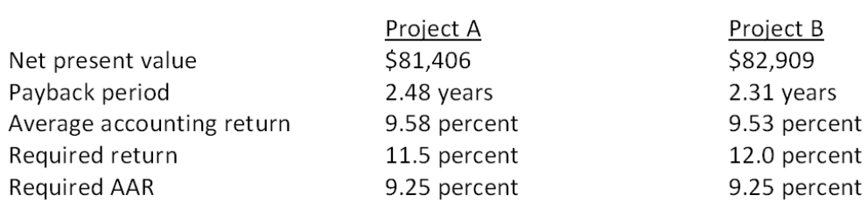
Isaac has been asked for his best recommendation given this information. His recommendation should be to accept:
A. both projects.
B. project B because it has the shortest payback period.
C. project B and reject project A based on their net present values.
D. project A and reject project B based on their average accounting returns.
E. neither project.

49. Which one of the following statements would generally be considered as accurate given independent projects with conventional cash flows?
A. The internal rate of return decision may contradict the net present value decision.
B. Business practice dictates that independent projects should have three distinct accept indicators before a project is actually implemented.
C. The payback decision rule could override the net present value decision rule should cash availability be limited.
D. The profitability index rule cannot be applied in this situation.
E. The projects cannot be accepted unless the average accounting return decision ruling is positive.

50. In actual practice, managers frequently use the:
I. average accounting return method because the information is so readily available.
II. internal rate of return because the results are easy to communicate and understand.
III. discounted payback because of its simplicity.
IV. net present value because it is considered by many to be the best method of analysis.
A. I and III only
B. II and III only
C. I, II, and IV only
D. II, III, and IV only
E. I, II, III, and IV

51. Kristi wants to start training her most junior assistant, Amy, in the art of project analysis. Amy has just started college and has no experience or background in business finance. To get her started, Kristi is going to assign the responsibility for all projects that have initial costs less than $1,000 to Amy to analyze. Which method is Kristi most apt to ask Amy to use in making her initial decisions?
A. discounted payback
B. profitability index
C. internal rate of return
D. payback
E. average accounting return

52. Which two methods of project analysis were the most widely used by CEO's as of 1999?
A. net present value and payback
B. internal rate of return and payback
C. net present value and average accounting return
D. internal rate of return and net present value
E. payback and average accounting return

53. Which two methods of project analysis are the most biased towards short-term projects?
A. net present value and internal rate of return
B. internal rate of return and profitability index
C. payback and discounted payback
D. net present value and discounted payback
E. discounted payback and profitability index

54. Western Beef Exporters is considering a project that has an NPV of $32,600, an IRR of 15.1 percent, and a payback period of 3.2 years. The required return is 14.5 percent and the required payback period is 3.0 years. Which one of the following statements correctly applies to this project?
A. The net present value indicates accept while the internal rate of return indicates reject.
B. Payback indicates acceptance.
C. The payback decision rule could override the accept decision indicated by the net present value.
D. The payback rule will automatically be ignored since both the net present value and the internal rate of return indicate an accept decision.
E. The net present value decision rule is the only rule that matters when making the final decision.

55. You are considering a project with conventional cash flows and the following characteristics:
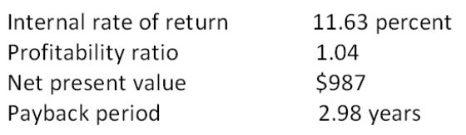
Which of the following statements is correct given this information?
I. The discount rate used in computing the net present value was less than 11.63 percent.
II. The discounted payback period must be less than 2.98 years.
III. The discount rate used in the computation of the profitability ratio was 11.63 percent.
IV. This project should be accepted as the internal rate of return exceeds the required return.
A. I and II only
B. III and IV only
C. I, II, and IV only
D. II, III, and IV only
E. I, II, III, and IV

56. Which of the following are definite indicators of an accept decision for an independent project with conventional cash flows?
I. positive net present value
II. profitability index greater than zero
III. internal rate of return greater than the required rate
IV. positive internal rate of return
A. I and III only
B. II and IV only
C. I, II, and III only
D. II, III, and IV only
E. I, II, III, and IV

57. What is the net present value of a project with the following cash flows if the required rate of return is 12 percent?
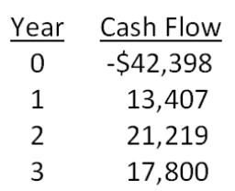
A. -$1,574.41
B. -$1,208.19
C. -$842.12
D. $729.09
E. $1,311.16

58. What is the net present value of a project that has an initial cash outflow of $34,900 and the following cash inflows? The required return is 15.35 percent.
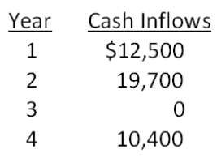
A. -$3,383.25
B. -$2,784.62
C. -$2,481.53
D. $52,311.08
E. $66,416.75

59. A project will produce cash inflows of $3,200 a year for 4 years with a final cash inflow of $5,700 in year 5. The project's initial cost is $9,500. What is the net present value of this project if the required rate of return is 16 percent?
A. -$311.02
B. $2,168.02
C. $4,650.11
D. $9,188.98
E. $21,168.02

60. You are considering the following two mutually exclusive projects. The required rate of return is 14.6 percent for project A and 13.8 percent for project B. Which project should you accept and why?
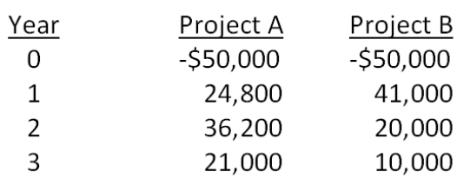
A. project A; because it has the higher required rate of return
B. project A; because its NPV is about $4,900 more than the NPV of project B
C. project B; because it has the largest total cash inflow
D. project B; because it has the largest cash inflow in year one
E. project B; because it has the lower required return

61. You are considering two mutually exclusive projects with the following cash flows. Which project(s) should you accept if the discount rate is 8.5 percent? What if the discount rate is 13 percent?
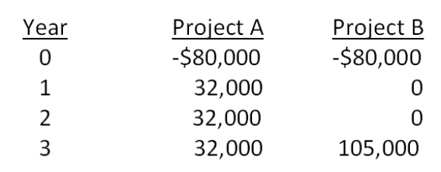
A. accept project A as it always has the higher NPV
B. accept project B as it always has the higher NPV
C. accept A at 8.5 percent and B at 13 percent
D. accept B at 8.5 percent and A at 13 percent
E. accept B at 8.5 percent and neither at 13 percent

62. Day Interiors is considering a project with the following cash flows. What is the IRR of this project?
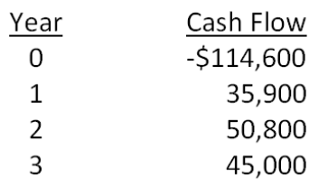
A. 6.42 percent
B. 7.03 percent
C. 7.48 percent
D. 8.22 percent
E. 8.56 percent

63. An investment has the following cash flows and a required return of 13 percent. Based on IRR, should this project be accepted? Why or why not?
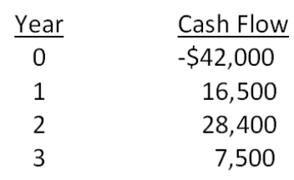
A. No; The IRR exceeds the required return by about 0.06 percent.
B. No; The IRR is less than the required return by about 0.94 percent.
C. Yes; The IRR exceeds the required return by about 0.06 percent.
D. Yes; The IRR exceeds the required return by about 0.94 percent.
E. Yes; The IRR is less than the required return by about 0.06 percent.

64. You are considering two independent projects with the following cash flows. The required return for both projects is 16 percent. Given this information, which one of the following statements is correct?
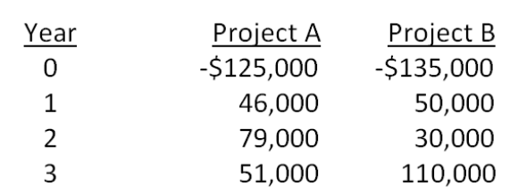
A. You should accept Project A and reject Project B based on their respective NPVs.
B. You should accept Project B and reject Project A based on their respective NPVs.
C. You should accept Project A and reject Project B based on their respective IRRs.
D. You should accept Project B and reject Project A based on their respective IRRs.
E. You should accept both projects based on both the NPV and IRR decision rules.

65. You are considering an investment with the following cash flows. If the required rate of return for this investment is 15.5 percent, should you accept the investment based solely on the internal rate of return rule? Why or why not?
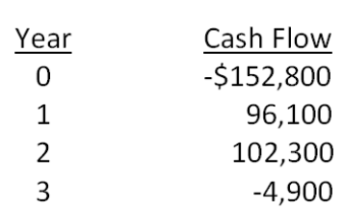
A. Yes; The IRR exceeds the required return.
B. Yes; The IRR is less than the required return.
C. No; The IRR is less than the required return.
D. No; The IRR exceeds the required return.
E. You cannot apply the IRR rule in this case.

66. Blue Water Systems is analyzing a project with the following cash flows. Should this project be accepted based on the discounting approach to the modified internal rate of return if the discount rate is 14 percent? Why or why not?
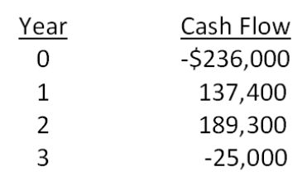
A. Yes; The MIRR is 13.48 percent.
B. Yes; The MIRR is 17.85 percent.
C. Yes; The MIRR is 21.23 percent.
D. No; The MIRR is 5.73 percent.
E. No; The MIRR is 17.85 percent.

67. Sheakley Industries is considering expanding its current line of business and has developed the following expected cash flows for the project. Should this project be accepted based on the discounting approach to the modified internal rate of return if the discount rate is 13.4 percent? Why or why not?
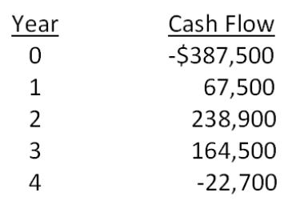
A. Yes; The MIRR is 6.50 percent.
B. Yes; The MIRR is 7.59 percent.
C. Yes; The MIRR is 8.23 percent.
D. No; The MIRR is 6.50 percent.
E. No; The MIRR is 7.59 percent.

68. Cool Water Drinks is considering a proposed project with the following cash flows. Should this project be accepted based on the combined approach to the modified internal rate of return if both the discount rate and the reinvestment rate are 12.6 percent? Why or why not?
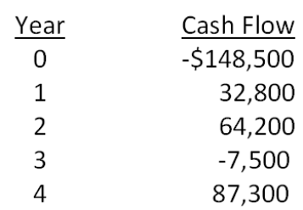
A. Yes; The MIRR is 8.81 percent.
B. Yes; The MIRR is 9.23 percent.
C. No; The MIRR is 8.81 percent.
D. No; The MIRR is 9.06 percent.
E. No; The MIRR is 9.23 percent.

69. Home Décor & More is considering a proposed project with the following cash flows. Should this project be accepted based on the combination approach to the modified internal rate of return if both the discount rate and the reinvestment rate are 16 percent? Why or why not?
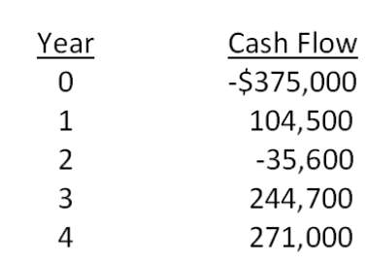
A. Yes; The MIRR is 14.78 percent.
B. Yes; The MIRR is 15.64 percent.
C. No; The MIRR is 12.91 percent.
D. No; The MIRR is 14.78 percent.
E. No; The MIRR is 15.64 percent.

70. What is the profitability index for an investment with the following cash flows given a 14.5 percent required return?
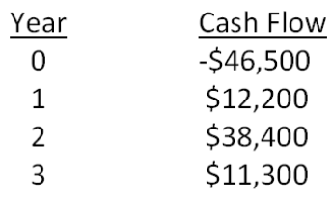
A. 0.94
B. 0.98
C. 1.02
D. 1.06
E. 1.11

71. Based on the profitability index rule, should a project with the following cash flows be accepted if the discount rate is 14 percent? Why or why not?
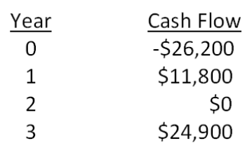
A. Yes; The PI is 0.96.
B. Yes; The PI is 1.04.
C. Yes; The PI is 1.08.
D. No; The PI is 0.96.
E. No; The PI is 1.04.

72. You are considering two independent projects both of which have been assigned a discount rate of 15 percent. Based on the profitability index, what is your recommendation concerning these projects?
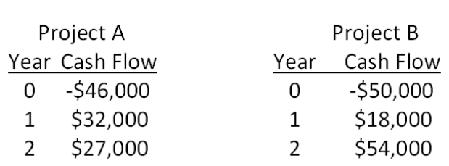
A. You should accept both projects.
B. You should reject both projects.
C. You should accept project A and reject project B.
D. You should accept project B and reject project A.
E. You should accept project A and be indifferent to project B.

73. You would like to invest in the following project.
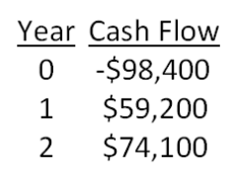
Sis, your boss, insists that only projects returning at least $1.06 in today's dollars for every $1 invested can be accepted. She also insists on applying a 14 percent discount rate to all cash flows. Based on these criteria, you should:
A. accept the project because the PI is 0.90.
B. accept the project because the PI is 1.04.
C. accept the project because the PI is 1.11.
D. reject the project because the PI is 0.90.
E. reject the project because the PI is 0.96.

74. It will cost $6,000 to acquire an ice cream cart. Cart sales are expected to be $3,600 a year for three years. After the three years, the cart is expected to be worthless as the expected life of the refrigeration unit is only three years. What is the payback period?
A. 1.48 years
B. 1.67 years
C. 1.82 years
D. 1.95 years
E. 2.00 years

75. You are considering a project with an initial cost of $7,800. What is the payback period for this project if the cash inflows are $1,100, $1,640, $3,800, and $4,500 a year over the next four years, respectively?
A. 3.21 years
B. 3.28 years
C. 3.36 years
D. 4.21 years
E. 4.29 years

76. A project has an initial cost of $6,500. The cash inflows are $900, $2,200, $3,600, and $4,100 over the next four years, respectively. What is the payback period?
A. 1.73 years
B. 2.51 years
C. 2.94 years
D. 3.51 years
E. 3.94 years

77. Alicia is considering adding toys to her gift shop. She estimates that the cost of inventory will be $7,500. The remodeling expenses and shelving costs are estimated at $1,500. Toy sales are expected to produce net cash inflows of $1,800, $2,700, $3,200, and $3,400 over the next four years, respectively. Should Alicia add toys to her store if she assigns a three-year payback period to this project? Why or why not?
A. No; The payback period is 2.93 years.
B. No; The payback period is 3.38 years.
C. Yes; The payback period is 2.93 years.
D. Yes; The payback period is 3.01 years.
E. Yes; The payback period is 3.38 years.

78. A project has an initial cost of $18,400 and produces cash inflows of $7,200, $8,900, and $7,500 over three years, respectively. What is the discounted payback period if the required rate of return is 16 percent?
A. 2.31 years
B. 2.45 years
C. 2.55 years
D. 2.62 years
E. never

79. Scott is considering a project that will produce cash inflows of $2,100 a year for 4 years. The project has a 12 percent required rate of return and an initial cost of $5,000. What is the discounted payback period?
A. 2.97 years
B. 3.11 years
C. 3.26 years
D. 4.38 years
E. never

80. J&J Enterprises is considering an investment that will cost $318,000. The investment produces no cash flows for the first year. In the second year, the cash inflow is $47,000. This inflow will increase to $198,000 and then $226,000 for the following two years, respectively, before ceasing permanently. The firm requires a 15.5 percent rate of return and has a required discounted payback period of three years. Should the project be accepted? Why or why not?
A. accept; The discounted payback period is 2.18 years.
B. accept; The discounted payback period is 2.32 years.
C. accept; The discounted payback period is 2.98 years.
D. reject; The discounted payback period is 2.18 years.
E. reject; The project never pays back on a discounted basis.

81. The Square Box is considering two projects, both of which have an initial cost of $35,000 and total cash inflows of $50,000. The cash inflows of project A are $5,000, $10,000, $15,000, and $20,000 over the next four years, respectively. The cash inflows for project B are $20,000, $15,000, $10,000, and $5,000 over the next four years, respectively. Which one of the following statements is correct if The Square Box requires a 12 percent rate of return and has a required discounted payback period of 3.5 years?
A. Both projects should be accepted.
B. Both projects should be rejected.
C. Project A should be accepted and project B should be rejected.
D. Project A should be rejected and project B should be accepted.
E. You should be indifferent to accepting either or both projects.

82. The Green Fiddle is considering a project that will produce sales of $87,000 a year for the next 4 years. The profit margin is estimated at 6 percent. The project will cost $90,000 and will be depreciated straight-line to a book value of zero over the life of the project. The firm has a required accounting return of 11 percent. This project should be _____ because the AAR is _____ percent.
A. rejected; 10.03
B. rejected; 10.25
C. rejected; 11.60
D. accepted; 10.25
E. accepted; 11.60

83. A project has an initial cost of $35,000 and a 3-year life. The company uses straight-line depreciation to a book value of zero over the life of the project. The projected net income from the project is $1,200, $2,300, and $1,800 a year for the next 3 years, respectively. What is the average accounting return?
A. 8.72 percent
B. 10.10 percent
C. 11.26 percent
D. 14.69 percent
E. 15.14 percent

84. A project produces annual net income of $46,200, $51,800, and $62,900 over its 3-year life, respectively. The initial cost of the project is $675,000. This cost is depreciated straight-line to a zero book value over three years. What is the average accounting rate of return if the required discount rate is 14.5 percent?
A. 15.89 percent
B. 16.67 percent
C. 18.98 percent
D. 20.25 percent
E. 23.84 percent

85. A project has average net income of $5,600 a year over its 6-year life. The initial cost of the project is $98,000 which will be depreciated using straight-line depreciation to a book value of zero over the life of the project. The firm wants to earn a minimum average accounting return of 11.5 percent. The firm should _____ the project because the AAR is _____ percent.
A. accept; 5.71
B. accept; 9.90
C. accept; 11.43
D. reject; 5.71
E. reject; 11.43

86. Colin is analyzing a project and has gathered the following data. Based on this data, what is the average accounting rate of return? The project's assets will be depreciated using straight-line depreciation to a zero book value over the life of the project.
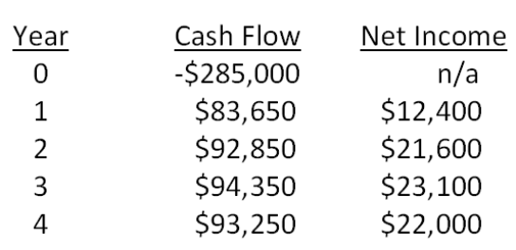
A. 6.94 percent
B. 13.88 percent
C. 15.66 percent
D. 27.75 percent
E. 31.31 percent

87. You are analyzing the following two mutually exclusive projects and have developed the following information. What is the crossover rate?
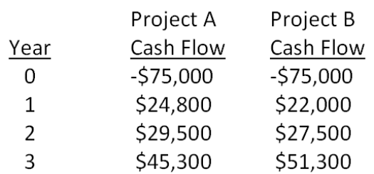
A. 13.17 percent
B. 13.33 percent
C. 14.32 percent
D. 14.96 percent
E. 15.20 percent

88. Boston Chicken is considering two mutually exclusive projects with the following cash flows. What is the crossover rate? If the required rate of return is lower than the crossover rate, which project should be accepted?
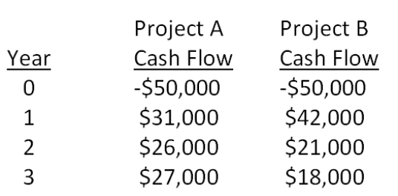
A. 14.72 percent; A
B. 14.72 percent; B
C. 15.99 percent; A
D. 15.99 percent; B
E. 16.08 percent; B

89. You are analyzing a project and have gathered the following data:
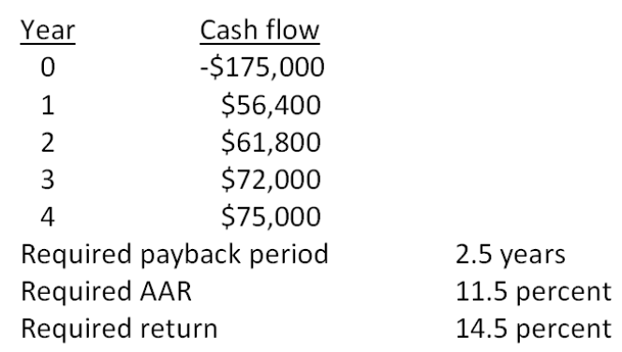
Based on the profitability index of _____ for this project, you should _____ the project.
A. 0.93; accept
B. 1.02; accept
C. 1.07; accept
D. 0.93; reject
E. 1.07; reject

90. You are analyzing a project and have gathered the following data:
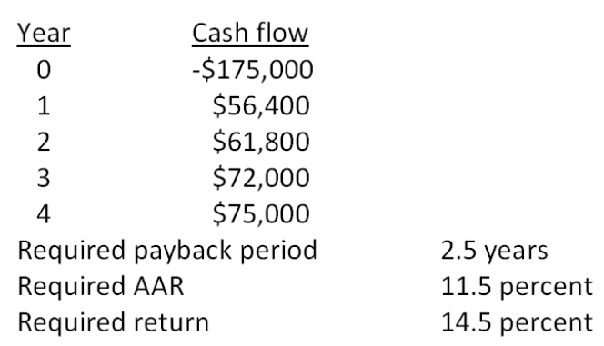
Based on the internal rate of return of _____ percent for this project, you should _____ the project.
A. 14.67; accept
B. 17.91; accept
C. 14.67; reject
D. 17.91; reject
E. 18.46; reject

91. You are analyzing a project and have gathered the following data:
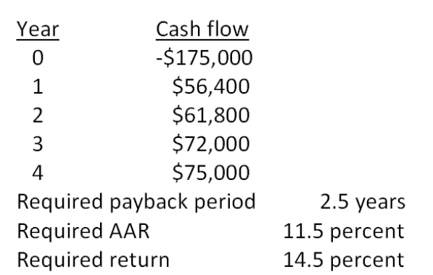
Based on the net present value of _____, you should _____ the project.
A. -$15,030.75; reject
B. -$12,995.84; reject
C. -$9,283.60; accept
D. $9,283.60; accept
E. $12,995.84; accept

92. You are analyzing a project and have gathered the following data:
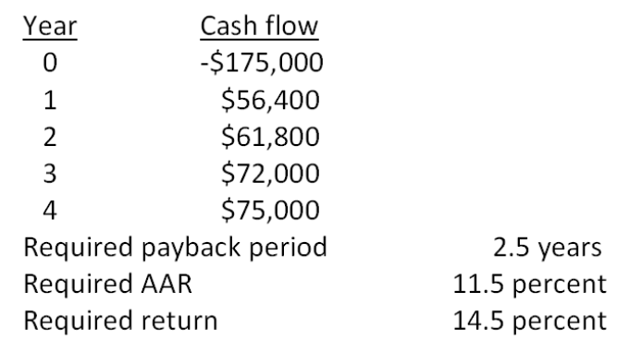
Based on the payback period of _____ years for this project, you should _____ the project.
A. 2.79; accept
B. 3.79; accept
C. 2.46; reject
D. 2.79; reject
E. 3.79; reject

93. You are considering the following two mutually exclusive projects. Both projects will be depreciated using straight-line depreciation to a zero book value over the life of the project. Neither project has any salvage value.
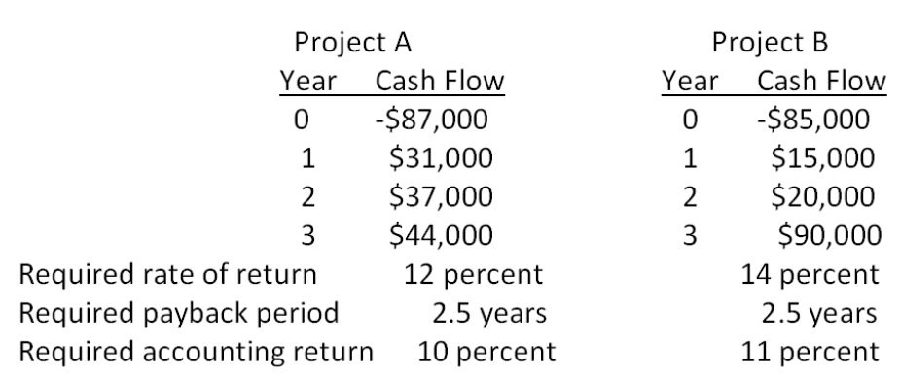
Should you accept or reject these projects based on net present value analysis?
A. accept Project A and reject Project B
B. reject Project A and accept Project B
C. accept both Projects A and B
D. reject both Projects A and B
E. You cannot make this decision based on net present value analysis.

94. You are considering the following two mutually exclusive projects. Both projects will be depreciated using straight-line depreciation to a zero book value over the life of the project.
Neither project has any salvage value.
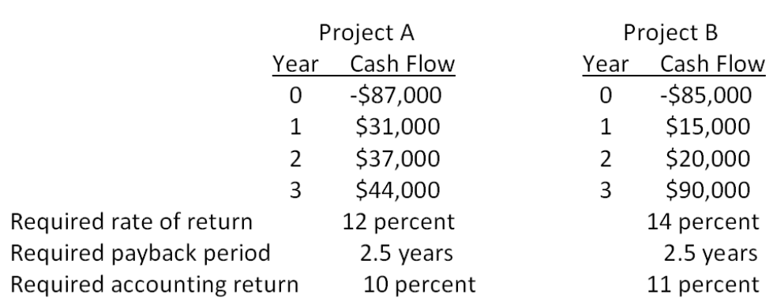
Should you accept or reject these projects based on IRR analysis?
A. accept Project A and reject Project B
B. reject Project A and accept Project B
C. accept both Projects A and B
D. reject both Projects A and B
E. You cannot make this decision based on internal rate of return analysis.

95. You are considering the following two mutually exclusive projects. Both projects will be depreciated using straight-line depreciation to a zero book value over the life of the project. Neither project has any salvage value.
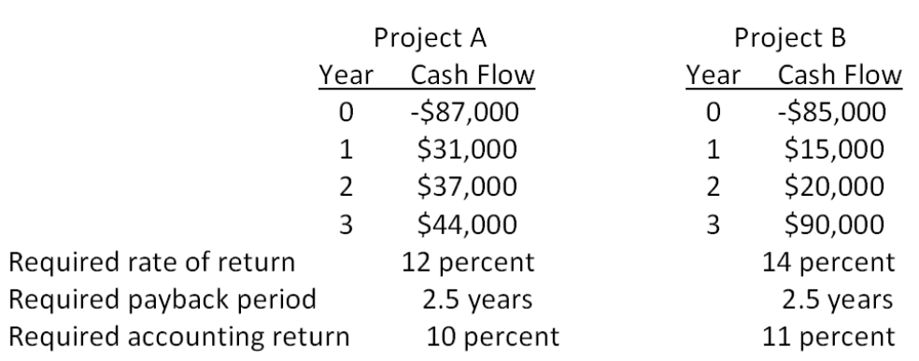
Should you accept or reject these projects based on payback analysis?
A. accept Project A and reject Project B
B. reject Project A and accept Project B
C. accept both Projects A and B
D. reject both Projects A and B
E. You cannot make this decision based on payback analysis.

96. You are considering the following two mutually exclusive projects. Both projects will be depreciated using straight-line depreciation to a zero book value over the life of the project. Neither project has any salvage value.
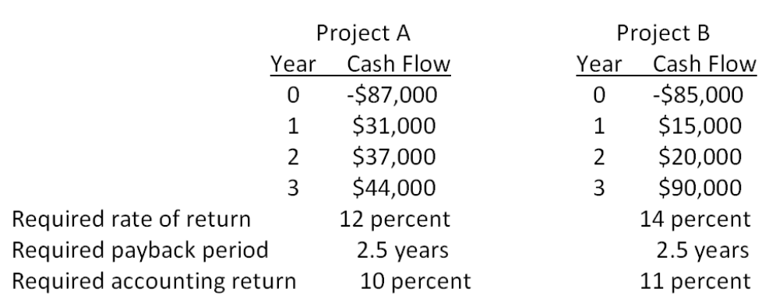
Should you accept or reject these projects based on the profitability index?
A. accept Project A and reject Project B
B. reject Project A and accept Project B
C. accept both Projects A and B
D. reject both Projects A and B
E. You cannot make this decision based on the profitability index.

97. You are considering the following two mutually exclusive projects. Both projects will be depreciated using straight-line depreciation to a zero book value over the life of the project. Neither project has any salvage value.
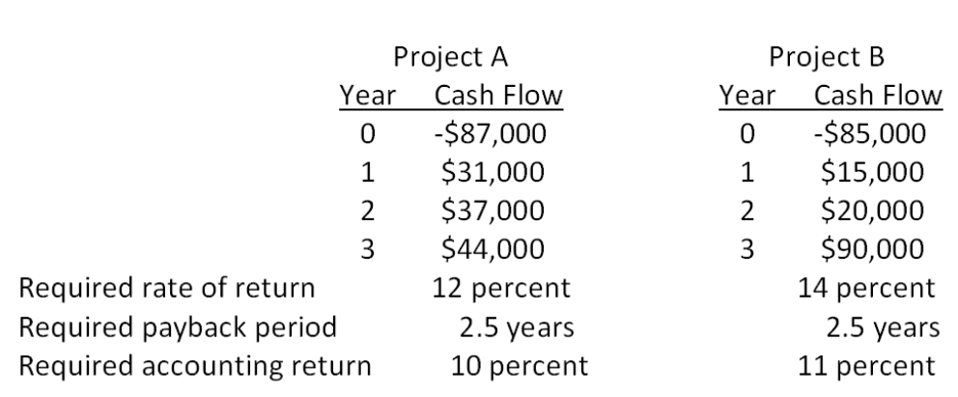
Should you accept or reject these projects based on the average accounting return?
A. accept Project A and reject Project B
B. reject Project A and accept Project B
C. accept both Projects A and B
D. reject both Projects A and B
E. You cannot make this decision based on the information provided.

98. Motor City Productions sells original automotive art on a prepaid basis as each piece is uniquely designed to the customer's specifications. For one project, the cash flows are estimated as follows. Based on the internal rate of return (IRR), should this project be accepted if the required return is 9 percent?
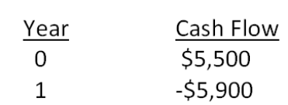
A. Accept the project.
B. Reject the project.
C. The IRR cannot be used to evaluate this type of project.
D. The firm should be indifferent to either accepting or rejecting this project.
E. Insufficient information is provided to make a decision based on IRR.

99. Rosa's Designer Gowns creates exquisite gowns for special occasions on a prepaid basis only. The required return is 8 percent. Rosa has estimated the cash flows for one gown as follows. Should Rosa sell this gown at the price she is currently considering based on the estimated internal rate of return (IRR)?
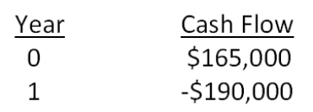
A. Rosa should sell the gown for $155,000.
B. Rose can sell the gown for as little as $153,819 and still earn her required return.
C. The gown must be sold for a minimum price of $175,926 if Rosa is to earn her required return.
D. The IRR decision rule cannot be applied to this project.
E. Insufficient information is provided to make a decision based on IRR.

Essay Questions
100. The profitability index (PI) of a project is 1.0. What do you know about the project's net present value (NPV) and its internal rate of return (IRR)?

101. Explain how the internal rate of return (IRR) decision rule is applied to projects with financing type cash flows.

102. Explain the differences and similarities between net present value (NPV) and the profitability index.

103. How does the net present value (NPV) decision rule relate to the primary goal of financial management, which is creating wealth for shareholders?

Multiple Choice Questions
104. An investment project provides cash flows of $1,190 per year for 10 years. If the initial cost is $8,000, what is the payback period?
A. 3.36 years
B. 5.28 years
C. 6.72 years
D. 8.13 years
E. never

105. An investment project costs $21,500 and has annual cash flows of $4,200 for 6 years. If the discount rate is 20 percent, what is the discounted payback period?
A. 4.41 years
B. 4.67 years
C. 5.12 years
D. 5.40 years
E. never

106. You're trying to determine whether to expand your business by building a new manufacturing plant. The plant has an installation cost of $12 million, which will be depreciated straight-line to zero over its 4-year life. The plant has projected net income of $1,095,000, $902,000, $1,412,000, and $1,724,000 over these 4 years. What is the average accounting return?
A. 10.70 percent
B. 15.63 percent
C. 18.87 percent
D. 21.39 percent
E. 23.05 percent

107. A firm evaluates all of its projects by applying the IRR rule. The required return for the following project is 21 percent. The IRR is _____ percent and the firm should ______ the project.
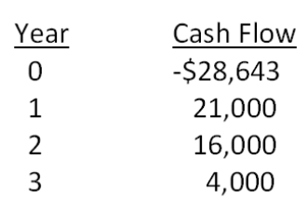
A. 23.67 percent; reject
B. 24.26 percent; accept
C. 24.26 percent; reject
D. 26.30 percent; accept
E. 26.30 percent; reject

108. A firm evaluates all of its projects by using the NPV decision rule. At a required return of 14 percent, the NPV for the following project is _____ and the firm should _____ the project.
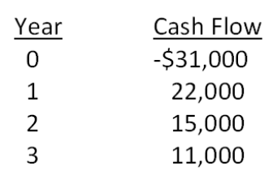
A. $5,684.22; reject
B. $7,264.95; accept
C. $7,264.95; reject
D. $9,616.93; accept
E. $9,616.93; reject

109. A project that provides annual cash flows of $12,600 for 12 years costs $67,150 today. At what rate would you be indifferent between accepting the project and rejecting it?
A. 15.28 percent
B. 15.40 percent
C. 15.51 percent
D. 15.62 percent
E. 15.74 percent

110. Hungry Hoagie's has identified the following two mutually exclusive projects:
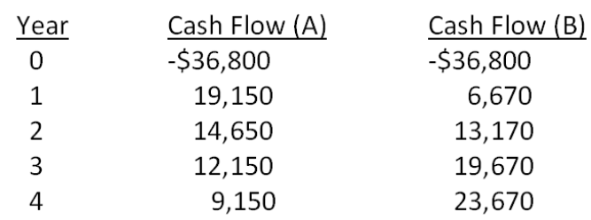
At what rate would you be indifferent between these two projects?
A. 17.34 percent
B. 17.72 percent
C. 19.41 percent
D. 19.69 percent
E. 20.28 percent

111. Consider the following two mutually exclusive projects:
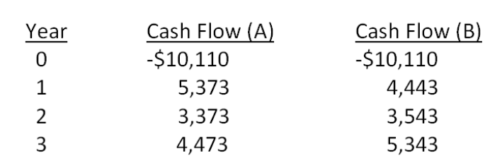
What is the crossover rate for these two projects?
A. 6.29 percent
B. 6.48 percent
C. 6.71 percent
D. 6.75 percent
E. 6.94 percent

112. The relevant discount rate for the following set of cash flows is 14 percent. What is the profitability index?
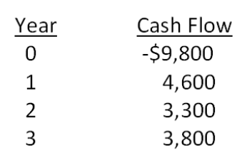
A. 0.89
B. 0.93
C. 0.99
D. 1.03
E. 1.07

113. Consider the following two mutually exclusive projects:
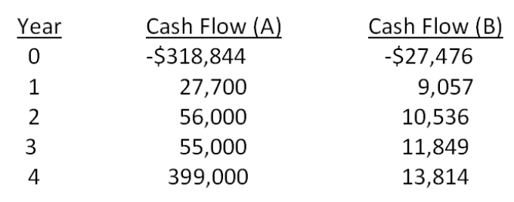
The required return is 15 percent for both projects. Which one of the following statements related to these projects is correct?
A. Because both the IRR and the PI imply accepting Project B, that project should be accepted.
B. The profitability rule implies accepting Project A.
C. The IRR decision rule should be used as the basis for selecting the project in this situation.
D. Only NPV implies accepting Project A.
E. NPV, IRR, and PI all imply accepting Project A.

114. An investment project has an installed cost of $518,297. The cash flows over the 4-year life of the investment are projected to be $287,636, $203,496, $103,802, and $92,556, respectively. What is the NPV of this project if the discount rate is zero percent?
A. $47,306
B. $72,418
C. $91,110
D. $128,415
E. $169,193

115. The Taxi Co. is evaluating a project with the following cash flows:
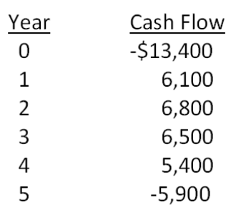
The company uses a 10 percent interest rate on all of its projects. What is the MIRR using the discounted approach?
A. 13.25 percent
B. 14.08 percent
C. 16.40 percent
D. 17.17 percent
E. 19.23 percent

116. The Chandler Group wants to set up a private cemetery business. According to the CFO, Barry M. Deep, business is "looking up". As a result, the cemetery project will provide a net cash inflow of $57,000 for the firm during the first year, and the cash flows are projected to grow at a rate of 7 percent per year forever. The project requires an initial investment of $759,000. The firm requires a 14 percent return on such undertakings. The company is somewhat unsure about the assumption of a 7 percent growth rate in its cash flows. At what constant rate of growth would the company just break even?
A. 4.48 percent
B. 5.29 percent
C. 5.61 percent
D. 6.49 percent
E. 6.75 percent

Chapter 09 Net Present Value and Other Investment Criteria Answer Key

Multiple Choice Questions
1. A project has an initial cost of $27,400 and a market value of $32,600. What is the difference between these two values called?
A. net present value
B. internal return
C. payback value
D. profitability index
E. discounted payback
Refer to section 9.1

AACSB: N/A
Bloom's: Knowledge
Difficulty: Basic
Learning Objective: 9-1
Section: 9.1
Topic: Net present value
2. Which one of the following methods of project analysis is defined as computing the value of a project based upon the present value of the project's anticipated cash flows?
A. constant dividend growth model
B. discounted cash flow valuation
C. average accounting return
D. expected earnings model
E. internal rate of return
Refer to section 9.1

AACSB: N/A
Bloom's: Knowledge
Difficulty: Basic
Learning Objective: 9-1
Section: 9.1
Topic: Discounted cash flow valuation
3. The length of time a firm must wait to recoup the money it has invested in a project is called the:
A. internal return period.
B. payback period.
C. profitability period.
D. discounted cash period.
E. valuation period.
Refer to section 9.2

AACSB: N/A
Bloom's: Knowledge
Difficulty: Basic
Learning Objective: 9-2
Section: 9.2
Topic: Payback period
4. The length of time a firm must wait to recoup, in present value terms, the money it has in invested in a project is referred to as the:
A. net present value period.
B. internal return period.
C. payback period.
D. discounted profitability period.
E. discounted payback period.
Refer to section 9.3

AACSB: N/A
Bloom's: Knowledge
Difficulty: Basic
Learning Objective: 9-3
Section: 9.3
Topic: Discounted payback period
5. A project's average net income divided by its average book value is referred to as the project's average:
A. net present value.
B. internal rate of return.
C. accounting return.
D. profitability index.
E. payback period.
Refer to section 9.4

AACSB: N/A
Bloom's: Knowledge
Difficulty: Basic
Learning Objective: 9-4
Section: 9.4
Topic: Average accounting return
6. The internal rate of return is defined as the:
A. maximum rate of return a firm expects to earn on a project.
B. rate of return a project will generate if the project in financed solely with internal funds.
C. discount rate that equates the net cash inflows of a project to zero.
D. discount rate which causes the net present value of a project to equal zero.
E. discount rate that causes the profitability index for a project to equal zero.
Refer to section 9.5

AACSB: N/A
Bloom's: Comprehension
Difficulty: Basic
Learning Objective: 9-5
Section: 9.5
Topic: Internal rate of return
7. You are viewing a graph that plots the NPVs of a project to various discount rates that could be applied to the project's cash flows. What is the name given to this graph?
A. project tract
B. projected risk profile
C. NPV profile
D. NPV route
E. present value sequence
Refer to section 9.5

AACSB: N/A
Bloom's: Knowledge
Difficulty: Basic
Learning Objective: 9-5
Section: 9.5
Topic: NPV profile
8. There are two distinct discount rates at which a particular project will have a zero net present value. In this situation, the project is said to:
A. have two net present value profiles.
B. have operational ambiguity.
C. create a mutually exclusive investment decision.
D. produce multiple economies of scale.
E. have multiple rates of return.
Refer to section 9.5

AACSB: N/A
Bloom's: Knowledge
Difficulty: Basic
Learning Objective: 9-5
Section: 9.5
Topic: Multiple rates of return
9. If a firm accepts Project A it will not be feasible to also accept Project B because both projects would require the simultaneous and exclusive use of the same piece of machinery. These projects are considered to be:
A. independent.
B. interdependent.
C. mutually exclusive.
D. economically scaled.
E. operationally distinct.
Refer to section 9.5

AACSB: N/A
Bloom's: Knowledge
Difficulty: Basic
Learning Objective: 9-5
Section: 9.5
Topic: Mutually exclusive
10. The present value of an investment's future cash flows divided by the initial cost of the investment is called the:
A. net present value.
B. internal rate of return.
C. average accounting return.
D. profitability index.
E. profile period.
Refer to section 9.6

AACSB: N/A
Bloom's: Knowledge
Difficulty: Basic
Learning Objective: 9-7
Section: 9.6
Topic: Profitability index
11. A project has a net present value of zero. Which one of the following best describes this project?
A. The project has a zero percent rate of return.
B. The project requires no initial cash investment.
C. The project has no cash flows.
D. The summation of all of the project's cash flows is zero.
E. The project's cash inflows equal its cash outflows in current dollar terms.
Refer to section 9.1

AACSB: N/A
Bloom's: Comprehension
Difficulty: Basic
Learning Objective: 9-1
Section: 9.1
Topic: Net present value
12. Which one of the following will decrease the net present value of a project?
A. increasing the value of each of the project's discounted cash inflows
B. moving each of the cash inflows back to a later time period
C. decreasing the required discount rate
D. increasing the project's initial cost at time zero
E. increasing the amount of the final cash inflow
Refer to section 9.1

AACSB: N/A
Bloom's: Comprehension
Difficulty: Basic
Learning Objective: 9-1
Section: 9.1
Topic: Net present value
13. Which one of the following methods determines the amount of the change a proposed project will have on the value of a firm?
A. net present value
B. discounted payback
C. internal rate of return
D. profitability index
E. payback
Refer to section 9.1

AACSB: N/A
Bloom's: Knowledge
Difficulty: Basic
Learning Objective: 9-1
Section: 9.1
Topic: Net present value
14. If a project has a net present value equal to zero, then:
A. the total of the cash inflows must equal the initial cost of the project.
B. the project earns a return exactly equal to the discount rate.
C. a decrease in the project's initial cost will cause the project to have a negative NPV.
D. any delay in receiving the projected cash inflows will cause the project to have a positive NPV.
E. the project's PI must be also be equal to zero.
Refer to sections 9.1 and 9.6

AACSB: N/A
Bloom's: Comprehension
Difficulty: Basic
Learning Objective: 9-1 and 9-7
Section: 9.1 and 9.6
Topic: Net present value and profitability index
15. Rossiter Restaurants is analyzing a project that requires $180,000 of fixed assets. When the project ends, those assets are expected to have an aftertax salvage value of $45,000. How is the $45,000 salvage value handled when computing the net present value of the project?
A. reduction in the cash outflow at time zero
B. cash inflow in the final year of the project
C. cash inflow for the year following the final year of the project
D. cash inflow prorated over the life of the project
E. not included in the net present value
Refer to section 9.1

AACSB: N/A
Bloom's: Knowledge
Difficulty: Basic
Learning Objective: 9-1
Section: 9.1
Topic: Net present value and salvage value
16. Which one of the following increases the net present value of a project?
A. an increase in the required rate of return
B. an increase in the initial capital requirement
C. a deferment of some cash inflows until a later year
D. an increase in the aftertax salvage value of the fixed assets
E. a reduction in the final cash inflow
Refer to section 9.1

AACSB: N/A
Bloom's: Comprehension
Difficulty: Basic
Learning Objective: 9-1
Section: 9.1
Topic: Net present value
17. Net present value:
A. is the best method of analyzing mutually exclusive projects.
B. is less useful than the internal rate of return when comparing different sized projects.
C. is the easiest method of evaluation for non-financial managers to use.
D. is less useful than the profitability index when comparing mutually exclusive projects.
E. is very similar in its methodology to the average accounting return.
Refer to section 9.1

AACSB: N/A
Bloom's: Knowledge
Difficulty: Basic
Learning Objective: 9-1
Section: 9.1
Topic: Net present value
18. Which one of the following is a project acceptance indicator given an independent project with investing type cash flows?
A. profitability index less than 1.0
B. project's internal rate of return less than the required return
C. discounted payback period greater than requirement
D. average accounting return that is less than the internal rate of return
E. modified internal rate of return that exceeds the required return
Refer to sections 9.3 through 9.6

AACSB: N/A
Bloom's: Comprehension
Difficulty: Basic
Learning Objective: 9-6
Section: 9.3 through 9.6
Topic: Decision rules
19. Why is payback often used as the sole method of analyzing a proposed small project?
A. Payback considers the time value of money.
B. All relevant cash flows are included in the payback analysis.
C. It is the only method where the benefits of the analysis outweigh the costs of that analysis.
D. Payback is the most desirable of the various financial methods of analysis.
E. Payback is focused on the long-term impact of a project.
Refer to section 9.2

AACSB: N/A
Bloom's: Comprehension
Difficulty: Basic
Learning Objective: 9-2
Section: 9.2
Topic: Payback
20. Which of the following are advantages of the payback method of project analysis?
I. works well for research and development projects
II. liquidity bias
III. ease of use
IV. arbitrary cutoff point
A. I and II only
B. I and III only
C. II and III only
D. II and IV only
E. II, III, and IV only
Refer to section 9.2

AACSB: N/A
Bloom's: Knowledge
Difficulty: Basic
Learning Objective: 9-2
Section: 9.2
Topic: Payback advantages
21. Samuelson Electronics has a required payback period of three years for all of its projects. Currently, the firm is analyzing two independent projects. Project A has an expected payback period of 2.8 years and a net present value of $6,800. Project B has an expected payback period of 3.1 years with a net present value of $28,400. Which projects should be accepted based on the payback decision rule?
A. Project A only
B. Project B only
C. Both A and B
D. Neither A nor B
E. Answer cannot be determined based on the information given.
Refer to section 9.2

AACSB: N/A
Bloom's: Comprehension
Difficulty: Basic
Learning Objective: 9-2
Section: 9.2
Topic: Payback decision rule
22. A project has a required payback period of three years. Which one of the following statements is correct concerning the payback analysis of this project?
A. The cash flows in each of the three years must exceed one-third of the project's initial cost if the project is to be accepted.
B. The cash flow in year three is ignored.
C. The project's cash flow in year three is discounted by a factor of (1 + R)³.
D. The cash flow in year two is valued just as highly as the cash flow in year one.
E. The project is acceptable whenever the payback period exceeds three years.
Refer to section 9.2

AACSB: N/A
Bloom's: Comprehension
Difficulty: Basic
Learning Objective: 9-2
Section: 9.2
Topic: Payback
23. A project has a discounted payback period that is equal to the required payback period. Given this, which of the following statements must be true?
I. The project must also be acceptable under the payback rule.
II. The project must have a profitability index that is equal to or greater than 1.0.
III. The project must have a zero net present value.
IV. The project's internal rate of return must equal the required return.
A. I only
B. I and II only
C. II and III only
D. I, III, and IV only
E. I, II, III, and IV
Refer to section 9.3

AACSB: N/A
Bloom's: Analysis
Difficulty: Intermediate
Learning Objective: 9-3
Section: 9.3
Topic: Discounted payback
24. Which one of the following statements related to payback and discounted payback is correct?
A. Payback is a better method of analysis than is discounted payback.
B. Discounted payback is used more frequently in business than is payback.
C. Discounted payback does not require a cutoff point like the payback method does.
D. Discounted payback is biased towards long-term projects while payback is biased towards short-term projects.
E. Payback is used more frequently even though discounted payback is a better method.
Refer to sections 9.2 and 9.3

AACSB: N/A
Bloom's: Comprehension
Difficulty: Basic
Learning Objective: 9-2 and 9-3
Section: 9.2 and 9.3
Topic: Payback and discounted payback
25. Applying the discounted payback decision rule to all projects may cause:
A. some positive net present value projects to be rejected.
B. the most liquid projects to be rejected in favor of the less liquid projects.
C. projects to be incorrectly accepted due to ignoring the time value of money.
D. a firm to become more long-term focused.
E. some projects to be accepted which would otherwise be rejected under the payback rule.
Refer to section 9.3

AACSB: N/A
Bloom's: Comprehension
Difficulty: Basic
Learning Objective: 9-3
Section: 9.3
Topic: Discounted payback
26. Which one of the following correctly applies to the average accounting rate of return?
A. It considers the time value of money.
B. It measures net income as a percentage of the sales generated by a project.
C. It is the best method of analyzing mutually exclusive projects from a financial point of view.
D. It is the primary methodology used in analyzing independent projects.
E. It can be compared to the return on assets ratio.
Refer to section 9.4

AACSB: N/A
Bloom's: Comprehension
Difficulty: Basic
Learning Objective: 9-4
Section: 9.4
Topic: Average accounting return
27. Which one of the following is an advantage of the average accounting return method of analysis?
A. easy availability of information needed for the computation
B. inclusion of time value of money considerations
C. the use of a cutoff rate as a benchmark
D. the use of pre-tax income in the computation
E. use of real, versus nominal, average income
Refer to section 9.4

AACSB: N/A
Bloom's: Knowledge
Difficulty: Basic
Learning Objective: 9-4
Section: 9.4
Topic: Average accounting return
28. Which of the following are considered weaknesses in the average accounting return method of project analysis?
I. exclusion of time value of money considerations
II. need of a cutoff rate
III. easily obtainable information for computation
IV. based on accounting values
A. I only
B. I and IV only
C. II and III only
D. I, II, and IV only
E. I, II, III, and IV
Refer to section 9.4

AACSB: N/A
Bloom's: Knowledge
Difficulty: Basic
Learning Objective: 9-4
Section: 9.4
Topic: Average accounting return
29. Which one of the following statements related to the internal rate of return (IRR) is correct?
A. The IRR yields the same accept and reject decisions as the net present value method given mutually exclusive projects.
B. A project with an IRR equal to the required return would reduce the value of a firm if accepted.
C. The IRR is equal to the required return when the net present value is equal to zero.
D. Financing type projects should be accepted if the IRR exceeds the required return.
E. The average accounting return is a better method of analysis than the IRR from a financial point of view.
Refer to section 9.5

AACSB: N/A
Bloom's: Comprehension
Difficulty: Basic
Learning Objective: 9-5
Section: 9.5
Topic: Internal rate of return
30. The internal rate of return:
A. may produce multiple rates of return when cash flows are conventional.
B. is best used when comparing mutually exclusive projects.
C. is rarely used in the business world today.
D. is principally used to evaluate small dollar projects.
E. is easy to understand.
Refer to section 9.5

AACSB: N/A
Bloom's: Comprehension
Difficulty: Basic
Learning Objective: 9-5
Section: 9.5
Topic: Internal rate of return
31. Tedder Mining has analyzed a proposed expansion project and determined that the internal rate of return is lower than the firm desires. Which one of the following changes to the project would be most expected to increase the project's internal rate of return?
A. decreasing the required discount rate
B. increasing the initial investment in fixed assets
C. condensing the firm's cash inflows into fewer years without lowering the total amount of those inflows
D. eliminating the salvage value
E. decreasing the amount of the final cash inflow
Refer to section 9.5

AACSB: N/A
Bloom's: Comprehension
Difficulty: Basic
Learning Objective: 9-5
Section: 9.5
Topic: Internal rate of return
32. The internal rate of return is:
A. the discount rate that makes the net present value of a project equal to the initial cash outlay.
B. equivalent to the discount rate that makes the net present value equal to one.
C. tedious to compute without the use of either a financial calculator or a computer.
D. highly dependent upon the current interest rates offered in the marketplace.
E. a better methodology than net present value when dealing with unconventional cash flows.
Refer to section 9.5

AACSB: N/A
Bloom's: Comprehension
Difficulty: Basic
Learning Objective: 9-5
Section: 9.5
Topic: Internal rate of return
33. Which of the following statements related to the internal rate of return (IRR) are correct?
I. The IRR method of analysis can be adapted to handle non-conventional cash flows.
II. The IRR that causes the net present value of the differences between two project's cash flows to equal zero is called the crossover rate.
III. The IRR tends to be used more than net present value simply because its results are easier to comprehend.
IV. Both the timing and the amount of a project's cash flows affect the value of the project's IRR.
A. I and II only
B. III and IV only
C. I, II, and III only
D. II, III, and IV only
E. I, II, III, and IV
Refer to section 9.5

AACSB: N/A
Bloom's: Comprehension
Difficulty: Intermediate
Learning Objective: 9-5
Section: 9.5
Topic: Internal rate of return
34. Douglass Interiors is considering two mutually exclusive projects and have determined that the crossover rate for these projects is 11.7 percent. Project A has an internal rate of return (IRR) of 15.3 percent and Project B has an IRR of 16.5 percent. Given this information, which one of the following statements is correct?
A. Project A should be accepted as its IRR is closer to the crossover point than is Project B's IRR.
B. Project B should be accepted as it has the higher IRR.
C. Both projects should be accepted as both of the project's IRRs exceed the crossover rate.
D. Neither project should be accepted since both of the project's IRRs exceed the crossover rate.
E. You cannot determine which project should be accepted given the information provided.
Refer to section 9.5

AACSB: N/A
Bloom's: Comprehension
Difficulty: Intermediate
Learning Objective: 9-5
Section: 9.5
Topic: Internal rate of return
35. You are comparing two mutually exclusive projects. The crossover point is 12.3 percent. You have determined that you should accept project A if the required return is 13.1 percent. This implies you should:
A. always accept project A.
B. be indifferent to the projects at any discount rate above 13.1 percent.
C. always accept project A if the required return exceeds the crossover rate.
D. accept project B only when the required return is equal to the crossover rate.
E. accept project B if the required return is less than 13.1 percent.
Refer to section 9.5

AACSB: N/A
Bloom's: Comprehension
Difficulty: Basic
Learning Objective: 9-5
Section: 9.5
Topic: Crossover rate
36. Graphing the crossover point helps explain:
A. why one project is always superior to another project.
B. how decisions concerning mutually exclusive projects are derived.
C. how the duration of a project affects the decision as to which project to accept.
D. how the net present value and the initial cash outflow of a project are related.
E. how the profitability index and the net present value are related.
Refer to section 9.5

AACSB: N/A
Bloom's: Comprehension
Difficulty: Basic
Learning Objective: 9-5
Section: 9.5
Topic: Crossover point
37. A project with financing type cash flows is typified by a project that has which one of the following characteristics?
A. conventional cash flows
B. cash flows that extend beyond the acceptable payback period
C. a year or more in the middle of a project where the cash flows are equal to zero
D. a cash inflow at time zero
E. cash inflows which are equal in amount
Refer to section 9.5

AACSB: N/A
Bloom's: Knowledge
Difficulty: Basic
Learning Objective: 9-5
Section: 9.5
Topic: Financing cash flows
38. Which of the following statements generally apply to the cash flows of a financing type project?
I. nonconventional cash flows
II. cash outflows exceed cash inflows prior to any time value adjustments
III. cash for services rendered is received prior to the cash that is spent providing the services
IV. the total of all cash flows must equal zero on an unadjusted basis
A. I only
B. I and III only
C. II and IV only
D. I, II, and III only
E. I, II, III, and IV
Refer to section 9.5

AACSB: N/A
Bloom's: Comprehension
Difficulty: Intermediate
Learning Objective: 9-5
Section: 9.5
Topic: Financing cash flows
39. Which one of the following statements is correct in relation to independent projects?
A. The internal rate of return cannot be used to determine the acceptability of a project that has financing type cash flows.
B. A project with investing type cash flows is acceptable if its internal rate of return exceeds the required return.
C. A project with financing type cash flows is acceptable if its internal rate of return exceeds the required return.
D. The net present value profile is upsloping for projects with both investing and financing type cash flows.
E. Projects with financing type cash flows are acceptable only when the internal rate of return is negative.
Refer to section 9.5

AACSB: N/A
Bloom's: Comprehension
Difficulty: Intermediate
Learning Objective: 9-5
Section: 9.5
Topic: Financing cash flows
40. The profitability index is most closely related to which one of the following?
A. payback
B. discounted payback
C. average accounting return
D. net present value
E. modified internal rate of return
Refer to section 9.6

AACSB: N/A
Bloom's: Knowledge
Difficulty: Basic
Learning Objective: 9-7
Section: 9.6
Topic: Profitability index
41. Roger's Meat Market is considering two independent projects. The profitability index decision rule indicates that both projects should be accepted. This result most likely does which one of the following?
A. conflicts with the results of the net present value decision rule
B. assumes the firm has sufficient funds to undertake both projects
C. agrees with the decision that would also apply if the projects were mutually exclusive
D. bases the accept/reject decision on the same variables as the average accounting return
E. fails to provide useful information as the firm must reject at least one of the projects
Refer to section 9.6

AACSB: N/A
Bloom's: Comprehension
Difficulty: Basic
Learning Objective: 9-7
Section: 9.6
Topic: Profitability index
42. Which one of the following methods of analysis provides the best information on the cost-benefit aspects of a project?
A. net present value
B. payback
C. internal rate of return
D. average accounting return
E. profitability index
Refer to section 9.6

AACSB: N/A
Bloom's: Knowledge
Difficulty: Basic
Learning Objective: 9-7
Section: 9.6
Topic: Profitability index
43. When the present value of the cash inflows exceeds the initial cost of a project, then the project should be:
A. accepted because the internal rate of return is positive.
B. accepted because the profitability index is greater than 1.
C. accepted because the profitability index is negative.
D. rejected because the internal rate of return is negative.
E. rejected because the net present value is negative.
Refer to section 9.6

AACSB: N/A
Bloom's: Comprehension
Difficulty: Basic
Learning Objective: 9-7
Section: 9.6
Topic: Profitability index
44. Which one of the following is the best example of two mutually exclusive projects?
A. building a retail store that is attached to a wholesale outlet
B. producing both plastic forks and spoons on the same assembly line at the same time
C. using an empty warehouse to store both raw materials and finished goods
D. promoting two products during the same television commercial
E. waiting until a machine finishes molding Product A before being able to mold Product B
Refer to section 9.5

AACSB: N/A
Bloom's: Comprehension
Difficulty: Basic
Learning Objective: 9-5
Section: 9.5
Topic: Mutually exclusive projects
45. Southern Chicken is considering two projects. Project A consists of creating an outdoor eating area on the unused portion of the restaurant's property. Project B would use that outdoor space for creating a drive-thru service window. When trying to decide which project to accept, the firm should rely most heavily on which one of the following analytical methods?
A. profitability index
B. internal rate of return
C. payback
D. net present value
E. accounting rate of return
Refer to section 9.5

AACSB: N/A
Bloom's: Comprehension
Difficulty: Basic
Learning Objective: 9-5
Section: 9.5
Topic: Mutually exclusive projects
46. Mutually exclusive projects are best defined as competing projects which:
A. would commence on the same day.
B. have the same initial start-up costs.
C. both require the total use of the same limited resource.
D. both have negative cash outflows at time zero.
E. have the same life span.
Refer to section 9.5

AACSB: N/A
Bloom's: Knowledge
Difficulty: Basic
Learning Objective: 9-5
Section: 9.5
Topic: Mutually exclusive projects
47. The final decision on which one of two mutually exclusive projects to accept ultimately depends upon which one of the following?
A. initial cost of each project
B. timing of the cash inflows
C. total cash inflows of each project
D. required rate of return
E. length of each project's life
Refer to section 9.5

AACSB: N/A
Bloom's: Comprehension
Difficulty: Basic
Learning Objective: 9-5
Section: 9.5
Topic: Mutually exclusive projects
48. Isaac has analyzed two mutually exclusive projects of similar size and has compiled the following information based on his analysis. Both projects have 3- year lives.
Isaac has been asked for his best recommendation given this information. His recommendation should be to accept:
A. both projects.
B. project B because it has the shortest payback period.
C. project B and reject project A based on their net present values.
D. project A and reject project B based on their average accounting returns.
E. neither project.
Refer to section 9.5

AACSB: N/A
Bloom's: Application
Difficulty: Basic
Learning Objective: 9-5
Section: 9.5
Topic: Mutually exclusive projects
49. Which one of the following statements would generally be considered as accurate given independent projects with conventional cash flows?
A. The internal rate of return decision may contradict the net present value decision.
B. Business practice dictates that independent projects should have three distinct accept indicators before a project is actually implemented.
C. The payback decision rule could override the net present value decision rule should cash availability be limited.
D. The profitability index rule cannot be applied in this situation.
E. The projects cannot be accepted unless the average accounting return decision ruling is positive.
Refer to section 9.7

AACSB: N/A
Bloom's: Comprehension
Difficulty: Basic
Learning Objective: 9-5
Section: 9.7
Topic: Independent projects
50. In actual practice, managers frequently use the:
I. average accounting return method because the information is so readily available.
II. internal rate of return because the results are easy to communicate and understand.
III. discounted payback because of its simplicity.
IV. net present value because it is considered by many to be the best method of analysis.
A. I and III only
B. II and III only
C. I, II, and IV only
D. II, III, and IV only
E. I, II, III, and IV
Refer to section 9.7

AACSB: N/A
Bloom's: Knowledge
Difficulty: Basic
Learning Objective: 9-1
Section: 9.7
Topic: Capital budgeting practice
51. Kristi wants to start training her most junior assistant, Amy, in the art of project analysis. Amy has just started college and has no experience or background in business finance. To get her started, Kristi is going to assign the responsibility for all projects that have initial costs less than $1,000 to Amy to analyze. Which method is Kristi most apt to ask Amy to use in making her initial decisions?
A. discounted payback
B. profitability index
C. internal rate of return
D. payback
E. average accounting return
Refer to section 9.7

AACSB: N/A
Bloom's: Application
Difficulty: Basic
Learning Objective: 9-2
Section: 9.7
Topic: Capital budgeting practice
52. Which two methods of project analysis were the most widely used by CEO's as of 1999?
A. net present value and payback
B. internal rate of return and payback
C. net present value and average accounting return
D. internal rate of return and net present value
E. payback and average accounting return
Refer to section 9.7

AACSB: N/A
Bloom's: Knowledge
Difficulty: Basic
Learning Objective: 9-1
Section: 9.7
Topic: Capital budgeting practice
53. Which two methods of project analysis are the most biased towards short-term projects?
A. net present value and internal rate of return
B. internal rate of return and profitability index
C. payback and discounted payback
D. net present value and discounted payback
E. discounted payback and profitability index
Refer to section 9.7

AACSB: N/A
Bloom's: Comprehension
Difficulty: Basic
Learning Objective: 9-2
Section: 9.7
Topic: Capital budgeting methods
54. Western Beef Exporters is considering a project that has an NPV of $32,600, an IRR of 15.1 percent, and a payback period of 3.2 years. The required return is 14.5 percent and the required payback period is 3.0 years. Which one of the following statements correctly applies to this project?
A. The net present value indicates accept while the internal rate of return indicates reject.
B. Payback indicates acceptance.
C. The payback decision rule could override the accept decision indicated by the net present value.
D. The payback rule will automatically be ignored since both the net present value and the internal rate of return indicate an accept decision.
E. The net present value decision rule is the only rule that matters when making the final decision.
Refer to section 9.7

AACSB: N/A
Bloom's: Comprehension
Difficulty: Basic
Learning Objective: 9-2
Section: 9.7
Topic: Capital budgeting practice
55. You are considering a project with conventional cash flows and the following characteristics:
Which of the following statements is correct given this information?
I. The discount rate used in computing the net present value was less than 11.63 percent.
II. The discounted payback period must be less than 2.98 years.
III. The discount rate used in the computation of the profitability ratio was 11.63 percent.
IV. This project should be accepted as the internal rate of return exceeds the required return.
A. I and II only
B. III and IV only
C. I, II, and IV only
D. II, III, and IV only
E. I, II, III, and IV
Refer to section 9.7

AACSB: N/A
Bloom's: Analysis
Difficulty: Intermediate
Learning Objective: 9-1
Section: 9.7
Topic: Capital budgeting methods
56. Which of the following are definite indicators of an accept decision for an independent project with conventional cash flows?
I. positive net present value
II. profitability index greater than zero
III. internal rate of return greater than the required rate
IV. positive internal rate of return
A. I and III only
B. II and IV only
C. I, II, and III only
D. II, III, and IV only
E. I, II, III, and IV
Refer to section 9.7

AACSB: N/A
Bloom's: Knowledge
Difficulty: Basic
Learning Objective: 9-1
Section: 9.7
Topic: Capital budgeting methods
57. What is the net present value of a project with the following cash flows if the required rate of return is 12 percent?
A. -$1,574.41
B. -$1,208.19
C. -$842.12
D. $729.09
E. $1,311.16
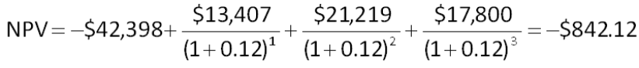

AACSB: Analytic
Bloom's: Application
Difficulty: Basic
Learning Objective: 9-1
Section: 9.1
Topic: Net present value
58. What is the net present value of a project that has an initial cash outflow of $34,900 and the following cash inflows? The required return is 15.35 percent.
A. -$3,383.25
B. -$2,784.62
C. -$2,481.53
D. $52,311.08
E. $66,416.75

AACSB: Analytic
Bloom's: Application
Difficulty: Basic
Learning Objective: 9-1
Section: 9.1
Topic: Net present value
59. A project will produce cash inflows of $3,200 a year for 4 years with a final cash inflow of $5,700 in year 5. The project's initial cost is $9,500. What is the net present value of this project if the required rate of return is 16 percent?
A. -$311.02
B. $2,168.02
C. $4,650.11
D. $9,188.98
E. $21,168.02
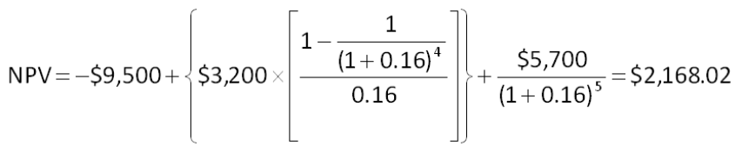

AACSB: Analytic
Bloom's: Application
Difficulty: Basic
Learning Objective: 9-1
Section: 9.1
Topic: Net present value
60. You are considering the following two mutually exclusive projects. The required rate of return is 14.6 percent for project A and 13.8 percent for project B. Which project should you accept and why?
A. project A; because it has the higher required rate of return
B. project A; because its NPV is about $4,900 more than the NPV of project B
C. project B; because it has the largest total cash inflow
D. project B; because it has the largest cash inflow in year one
E. project B; because it has the lower required return
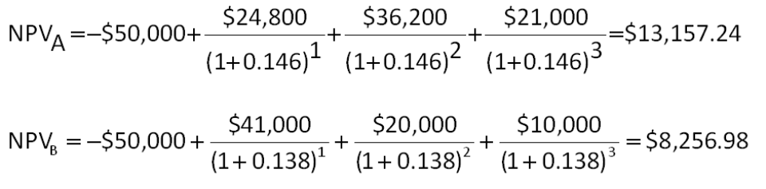

AACSB: Analytic
Bloom's: Application
Difficulty: Basic
Learning Objective: 9-1
Section: 9.1
Topic: Net present value
61. You are considering two mutually exclusive projects with the following cash flows. Which project(s) should you accept if the discount rate is 8.5 percent? What if the discount rate is 13 percent?
A. accept project A as it always has the higher NPV
B. accept project B as it always has the higher NPV
C. accept A at 8.5 percent and B at 13 percent
D. accept B at 8.5 percent and A at 13 percent
E. accept B at 8.5 percent and neither at 13 percent
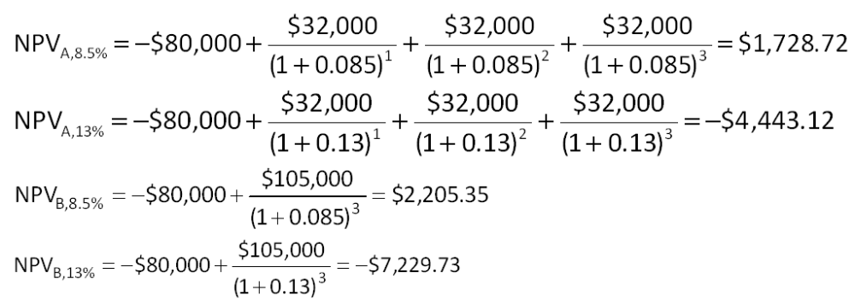

AACSB: Analytic
Bloom's: Analysis
Difficulty: Basic
Learning Objective: 9-1
Section: 9.1
Topic: Net present value
62. Day Interiors is considering a project with the following cash flows. What is the IRR of this project?
A. 6.42 percent
B. 7.03 percent
C. 7.48 percent
D. 8.22 percent
E. 8.56 percent
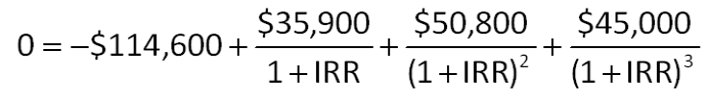

AACSB: Analytic
Bloom's: Application
Difficulty: Basic
Learning Objective: 9-5
Section: 9.5
Topic: Internal rate of return
63. An investment has the following cash flows and a required return of 13 percent. Based on IRR, should this project be accepted? Why or why not?
A. No; The IRR exceeds the required return by about 0.06 percent.
B. No; The IRR is less than the required return by about 0.94 percent.
C. Yes; The IRR exceeds the required return by about 0.06 percent.
D. Yes; The IRR exceeds the required return by about 0.94 percent.
E. Yes; The IRR is less than the required return by about 0.06 percent.
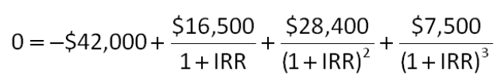

AACSB: Analytic
Bloom's: Application
Difficulty: Basic
Learning Objective: 9-5
Section: 9.5
Topic: Internal rate of return
64. You are considering two independent projects with the following cash flows. The required return for both projects is 16 percent. Given this information, which one of the following statements is correct?
A. You should accept Project A and reject Project B based on their respective NPVs.
B. You should accept Project B and reject Project A based on their respective NPVs.
C. You should accept Project A and reject Project B based on their respective IRRs.
D. You should accept Project B and reject Project A based on their respective IRRs.
E. You should accept both projects based on both the NPV and IRR decision rules.
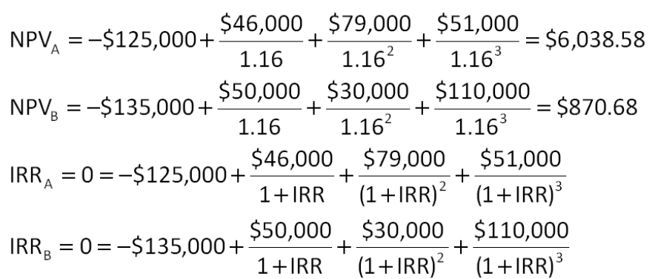

AACSB: Analytic
Bloom's: Application
Difficulty: Basic
Learning Objective: 9-1 and 9-5
Section: 9.1 and 9.5
Topic: Net present value and internal rate of return
65. You are considering an investment with the following cash flows. If the required rate of return for this investment is 15.5 percent, should you accept the investment based solely on the internal rate of return rule? Why or why not?
A. Yes; The IRR exceeds the required return.
B. Yes; The IRR is less than the required return.
C. No; The IRR is less than the required return.
D. No; The IRR exceeds the required return.
E. You cannot apply the IRR rule in this case.
Since the cash flow direction changes twice, there are two IRRs. Thus, the IRR rule cannot be used to determine acceptance or rejection.

AACSB: Analytic
Bloom's: Application
Difficulty: Basic
Learning Objective: 9-5
Section: 9.5
Topic: Internal rate of return
66. Blue Water Systems is analyzing a project with the following cash flows. Should this project be accepted based on the discounting approach to the modified internal rate of return if the discount rate is 14 percent? Why or why not?
A. Yes; The MIRR is 13.48 percent.
B. Yes; The MIRR is 17.85 percent.
C. Yes; The MIRR is 21.23 percent.
D. No; The MIRR is 5.73 percent.
E. No; The MIRR is 17.85 percent.
The modified cash flows will be:

AACSB: Analytic
Bloom's: Application
Difficulty: Basic
Learning Objective: 9-6
Section: 9.5
Topic: Modified internal rate of return
67. Sheakley Industries is considering expanding its current line of business and has developed the following expected cash flows for the project. Should this project be accepted based on the discounting approach to the modified internal rate of return if the discount rate is 13.4 percent? Why or why not?
A. Yes; The MIRR is 6.50 percent.
B. Yes; The MIRR is 7.59 percent.
C. Yes; The MIRR is 8.23 percent.
D. No; The MIRR is 6.50 percent.
E. No; The MIRR is 7.59 percent.
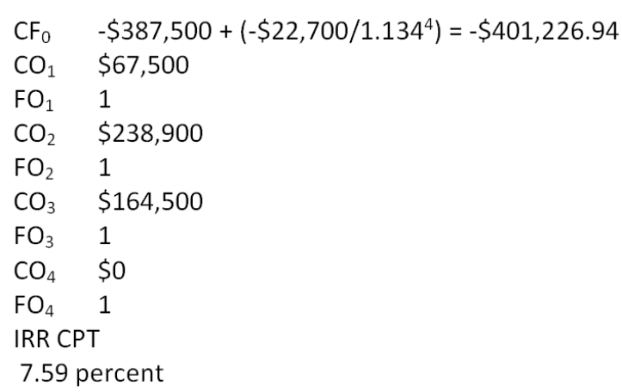

AACSB: Analytic
Bloom's: Application
Difficulty: Basic
Learning Objective: 9-6
Section: 9.5
Topic: Modified internal rate of return
68. Cool Water Drinks is considering a proposed project with the following cash flows. Should this project be accepted based on the combined approach to the modified internal rate of return if both the discount rate and the reinvestment rate are 12.6 percent? Why or why not?
A. Yes; The MIRR is 8.81 percent.
B. Yes; The MIRR is 9.23 percent.
C. No; The MIRR is 8.81 percent.
D. No; The MIRR is 9.06 percent.
E. No; The MIRR is 9.23 percent.
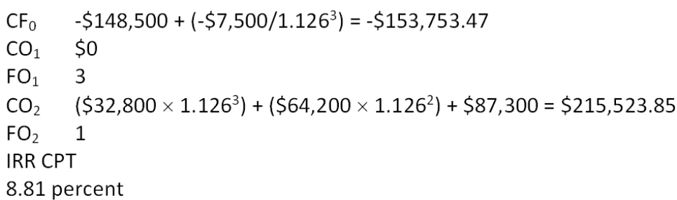

AACSB: Analytic
Bloom's: Application
Difficulty: Basic
Learning Objective: 9-6
Section: 9.5
Topic: Modified internal rate of return
69. Home Décor & More is considering a proposed project with the following cash flows. Should this project be accepted based on the combination approach to the modified internal rate of return if both the discount rate and the reinvestment rate are 16 percent? Why or why not?
A. Yes; The MIRR is 14.78 percent.
B. Yes; The MIRR is 15.64 percent.
C. No; The MIRR is 12.91 percent.
D. No; The MIRR is 14.78 percent.
E. No; The MIRR is 15.64 percent.
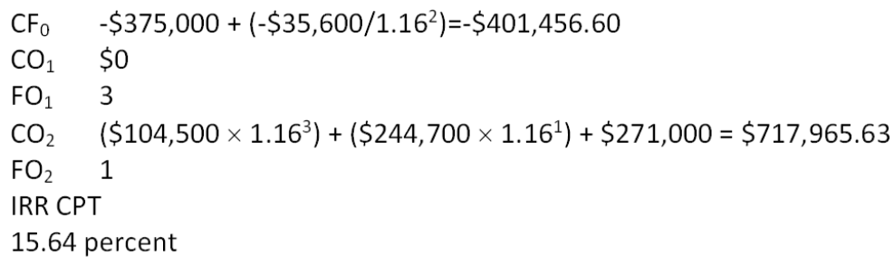

AACSB: Analytic
Bloom's: Application
Difficulty: Basic
Learning Objective: 9-6
Section: 9.5
Topic: Modified internal rate of return
70. What is the profitability index for an investment with the following cash flows given a 14.5 percent required return?
A. 0.94
B. 0.98
C. 1.02
D. 1.06
E. 1.11
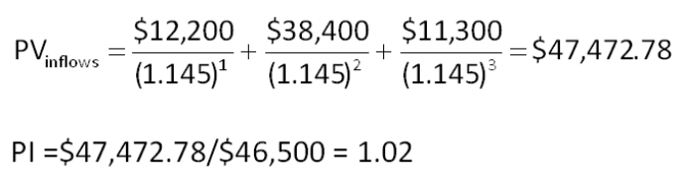

AACSB: Analytic
Bloom's: Application
Difficulty: Basic
Learning Objective: 9-7
Section: 9.6
Topic: Profitability index
71. Based on the profitability index rule, should a project with the following cash flows be accepted if the discount rate is 14 percent? Why or why not?
A. Yes; The PI is 0.96.
B. Yes; The PI is 1.04.
C. Yes; The PI is 1.08.
D. No; The PI is 0.96.
E. No; The PI is 1.04.
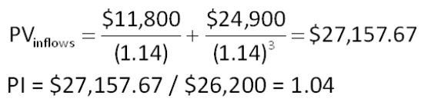

AACSB: Analytic
Bloom's: Application
Difficulty: Basic
Learning Objective: 9-7
Section: 9.6
Topic: Profitability index
72. You are considering two independent projects both of which have been assigned a discount rate of 15 percent. Based on the profitability index, what is your recommendation concerning these projects?
A. You should accept both projects.
B. You should reject both projects.
C. You should accept project A and reject project B.
D. You should accept project B and reject project A.
E. You should accept project A and be indifferent to project B.
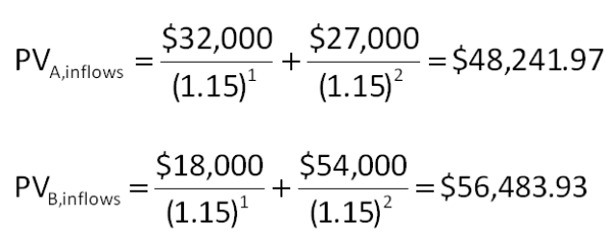

AACSB: Analytic
Bloom's: Analysis
Difficulty: Intermediate
Learning Objective: 9-7
Section: 9.6
Topic: Profitability index
73. You would like to invest in the following project.
Sis, your boss, insists that only projects returning at least $1.06 in today's dollars for every $1 invested can be accepted. She also insists on applying a 14 percent discount rate to all cash flows. Based on these criteria, you should:
A. accept the project because the PI is 0.90.
B. accept the project because the PI is 1.04.
C. accept the project because the PI is 1.11.
D. reject the project because the PI is 0.90.
E. reject the project because the PI is 0.96.
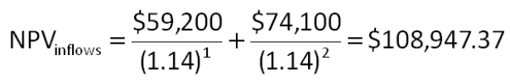

AACSB: Analytic
Bloom's: Application
Difficulty: Basic
Learning Objective: 9-7
Section: 9.6
Topic: Profitability index
74. It will cost $6,000 to acquire an ice cream cart. Cart sales are expected to be $3,600 a year for three years. After the three years, the cart is expected to be worthless as the expected life of the refrigeration unit is only three years. What is the payback period?
A. 1.48 years
B. 1.67 years
C. 1.82 years
D. 1.95 years
E. 2.00 years
Payback period = $6,000/$3,600 = 1.67 years

AACSB: Analytic
Bloom's: Application
Difficulty: Basic
Learning Objective: 9-2
Section: 9.2
Topic: Payback period
75. You are considering a project with an initial cost of $7,800. What is the payback period for this project if the cash inflows are $1,100, $1,640, $3,800, and $4,500 a year over the next four years, respectively?
A. 3.21 years
B. 3.28 years
C. 3.36 years
D. 4.21 years
E. 4.29 years


AACSB: Analytic
Bloom's: Application
Difficulty: Basic
Learning Objective: 9-2
Section: 9.2
Topic: Payback period
76. A project has an initial cost of $6,500. The cash inflows are $900, $2,200, $3,600, and $4,100 over the next four years, respectively. What is the payback period?
A. 1.73 years
B. 2.51 years
C. 2.94 years
D. 3.51 years
E. 3.94 years


AACSB: Analytic
Bloom's: Application
Difficulty: Basic
Learning Objective: 9-2
Section: 9.2
Topic: Payback period
77. Alicia is considering adding toys to her gift shop. She estimates that the cost of inventory will be $7,500. The remodeling expenses and shelving costs are estimated at $1,500. Toy sales are expected to produce net cash inflows of $1,800, $2,700, $3,200, and $3,400 over the next four years, respectively. Should Alicia add toys to her store if she assigns a three-year payback period to this project? Why or why not?
A. No; The payback period is 2.93 years.
B. No; The payback period is 3.38 years.
C. Yes; The payback period is 2.93 years.
D. Yes; The payback period is 3.01 years.
E. Yes; The payback period is 3.38 years.

AACSB: Analytic
Bloom's: Application
Difficulty: Basic
Learning Objective: 9-2
Section: 9.2
Topic: Payback period
78. A project has an initial cost of $18,400 and produces cash inflows of $7,200, $8,900, and $7,500 over three years, respectively. What is the discounted payback period if the required rate of return is 16 percent?
A. 2.31 years
B. 2.45 years
C. 2.55 years
D. 2.62 years
E. never
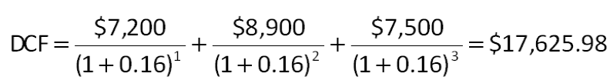

AACSB: Analytic
Bloom's: Application
Difficulty: Basic
Learning Objective: 9-3
Section: 9.3
Topic: Discounted payback
79. Scott is considering a project that will produce cash inflows of $2,100 a year for 4 years. The project has a 12 percent required rate of return and an initial cost of $5,000. What is the discounted payback period?
A. 2.97 years
B. 3.11 years
C. 3.26 years
D. 4.38 years
E. never
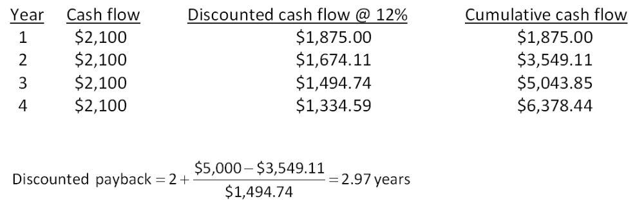

AACSB: Analytic
Bloom's: Application
Difficulty: Basic
Learning Objective: 9-3
Section: 9.3
Topic: Discounted payback
80. J&J Enterprises is considering an investment that will cost $318,000. The investment produces no cash flows for the first year. In the second year, the cash inflow is $47,000. This inflow will increase to $198,000 and then $226,000 for the following two years, respectively, before ceasing permanently. The firm requires a 15.5 percent rate of return and has a required discounted payback period of three years. Should the project be accepted? Why or why not?
A. accept; The discounted payback period is 2.18 years.
B. accept; The discounted payback period is 2.32 years.
C. accept; The discounted payback period is 2.98 years.
D. reject; The discounted payback period is 2.18 years.
E. reject; The project never pays back on a discounted basis.
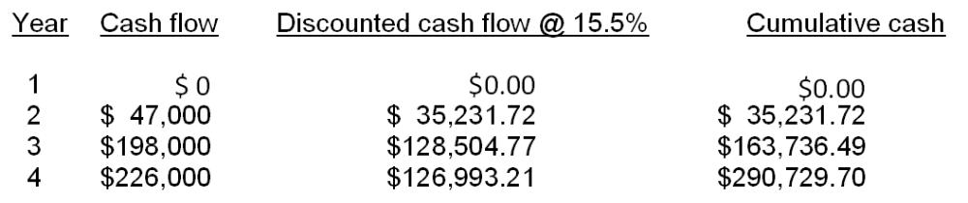
The project should be rejected because it never pays back on a discounted basis.

AACSB: Analytic
Bloom's: Application
Difficulty: Basic
Learning Objective: 9-3
Section: 9.3
Topic: Discounted payback
81. The Square Box is considering two projects, both of which have an initial cost of $35,000 and total cash inflows of $50,000. The cash inflows of project A are $5,000, $10,000, $15,000, and $20,000 over the next four years, respectively. The cash inflows for project B are $20,000, $15,000, $10,000, and $5,000 over the next four years, respectively. Which one of the following statements is correct if The Square Box requires a 12 percent rate of return and has a required discounted payback period of 3.5 years?
A. Both projects should be accepted.
B. Both projects should be rejected.
C. Project A should be accepted and project B should be rejected.
D. Project A should be rejected and project B should be accepted.
E. You should be indifferent to accepting either or both projects.
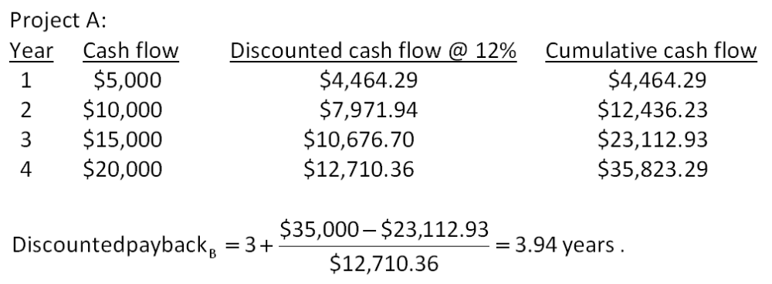

AACSB: Analytic
Bloom's: Analysis
Difficulty: Intermediate
Learning Objective: 9-3
Section: 9.3
Topic: Discounted payback
82. The Green Fiddle is considering a project that will produce sales of $87,000 a year for the next 4 years. The profit margin is estimated at 6 percent. The project will cost $90,000 and will be depreciated straight-line to a book value of zero over the life of the project. The firm has a required accounting return of 11 percent. This project should be _____ because the AAR is _____ percent.
A. rejected; 10.03
B. rejected; 10.25
C. rejected; 11.60
D. accepted; 10.25
E. accepted; 11.60
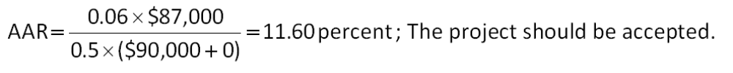

AACSB: Analytic
Bloom's: Application
Difficulty: Basic
Learning Objective: 9-4
Section: 9.4
Topic: Average accounting return
83. A project has an initial cost of $35,000 and a 3-year life. The company uses straight-line depreciation to a book value of zero over the life of the project. The projected net income from the project is $1,200, $2,300, and $1,800 a year for the next 3 years, respectively. What is the average accounting return?
A. 8.72 percent
B. 10.10 percent
C. 11.26 percent
D. 14.69 percent
E. 15.14 percent
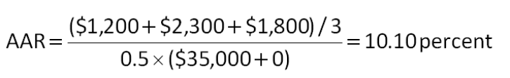

AACSB: Analytic
Bloom's: Application
Difficulty: Basic
Learning Objective: 9-4
Section: 9.4
Topic: Average accounting return
84. A project produces annual net income of $46,200, $51,800, and $62,900 over its 3-year life, respectively. The initial cost of the project is $675,000. This cost is depreciated straight-line to a zero book value over three years. What is the average accounting rate of return if the required discount rate is 14.5 percent?
A. 15.89 percent
B. 16.67 percent
C. 18.98 percent
D. 20.25 percent
E. 23.84 percent
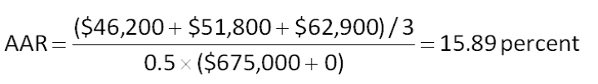

AACSB: Analytic
Bloom's: Application
Difficulty: Basic
Learning Objective: 9-4
Section: 9.4
Topic: Average accounting return
85. A project has average net income of $5,600 a year over its 6-year life. The initial cost of the project is $98,000 which will be depreciated using straight-line depreciation to a book value of zero over the life of the project. The firm wants to earn a minimum average accounting return of 11.5 percent. The firm should _____ the project because the AAR is _____ percent.
A. accept; 5.71
B. accept; 9.90
C. accept; 11.43
D. reject; 5.71
E. reject; 11.43
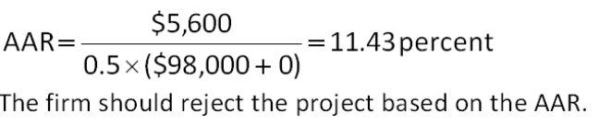

AACSB: Analytic
Bloom's: Application
Difficulty: Basic
Learning Objective: 9-4
Section: 9.4
Topic: Average accounting return
86. Colin is analyzing a project and has gathered the following data. Based on this data, what is the average accounting rate of return? The project's assets will be depreciated using straight-line depreciation to a zero book value over the life of the project.
A. 6.94 percent
B. 13.88 percent
C. 15.66 percent
D. 27.75 percent
E. 31.31 percent
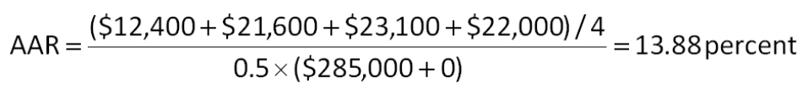

AACSB: Analytic
Bloom's: Application
Difficulty: Basic
Learning Objective: 9-4
Section: 9.4
Topic: Average accounting return
87. You are analyzing the following two mutually exclusive projects and have developed the following information. What is the crossover rate?
A. 13.17 percent
B. 13.33 percent
C. 14.32 percent
D. 14.96 percent
E. 15.20 percent
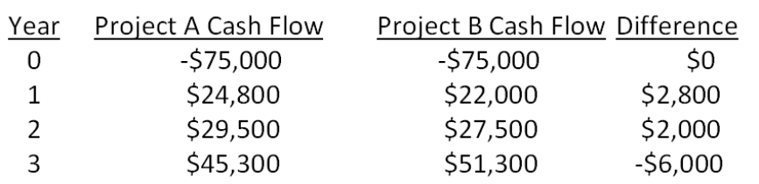

AACSB: Analytic
Bloom's: Analysis
Difficulty: Basic
Learning Objective: 9-5
Section: 9.5
Topic: Crossover rate
88. Boston Chicken is considering two mutually exclusive projects with the following cash flows. What is the crossover rate? If the required rate of return is lower than the crossover rate, which project should be accepted?
A. 14.72 percent; A
B. 14.72 percent; B
C. 15.99 percent; A
D. 15.99 percent; B
E. 16.08 percent; B
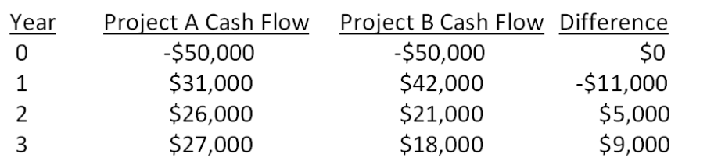

AACSB: Analytic
Bloom's: Analysis
Difficulty: Basic
Learning Objective: 9-5
Section: 9.5
Topic: Crossover rate
89. You are analyzing a project and have gathered the following data:
Based on the profitability index of _____ for this project, you should _____ the project.
A. 0.93; accept
B. 1.02; accept
C. 1.07; accept
D. 0.93; reject
E. 1.07; reject
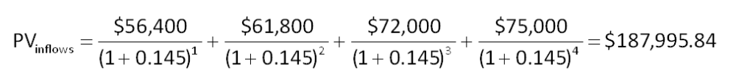

AACSB: Analytic
Bloom's: Application
Difficulty: Basic
Learning Objective: 9-7
Section: 9.6
Topic: Profitability index rule
90. You are analyzing a project and have gathered the following data:
Based on the internal rate of return of _____ percent for this project, you should _____ the project.
A. 14.67; accept
B. 17.91; accept
C. 14.67; reject
D. 17.91; reject
E. 18.46; reject
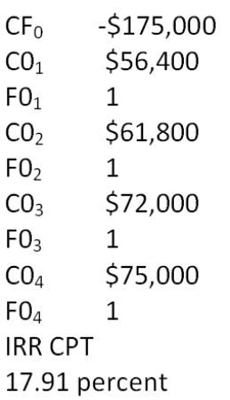

AACSB: Analytic
Bloom's: Application
Difficulty: Basic
Learning Objective: 9-5
Section: 9.5
Topic: Internal rate of return rule
91. You are analyzing a project and have gathered the following data:
Based on the net present value of _____, you should _____ the project.
A. -$15,030.75; reject
B. -$12,995.84; reject
C. -$9,283.60; accept
D. $9,283.60; accept
E. $12,995.84; accept

AACSB: Analytic
Bloom's: Application
Difficulty: Basic
Learning Objective: 9-1
Section: 9.1
Topic: Net present value rule
92. You are analyzing a project and have gathered the following data:
Based on the payback period of _____ years for this project, you should _____ the project.
A. 2.79; accept
B. 3.79; accept
C. 2.46; reject
D. 2.79; reject
E. 3.79; reject


AACSB: Analytic
Bloom's: Application
Difficulty: Basic
Learning Objective: 9-2
Section: 9.2
Topic: Payback rule
93. You are considering the following two mutually exclusive projects. Both projects will be depreciated using straight-line depreciation to a zero book value over the life of the project. Neither project has any salvage value.
Should you accept or reject these projects based on net present value analysis?
A. accept Project A and reject Project B
B. reject Project A and accept Project B
C. accept both Projects A and B
D. reject both Projects A and B
E. You cannot make this decision based on net present value analysis.
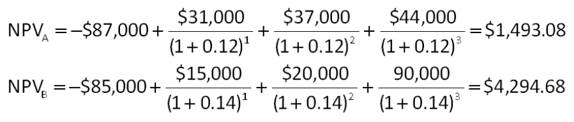

AACSB: Analytic
Bloom's: Analysis
Difficulty: Basic
Learning Objective: 9-1
Section: 9.1
Topic: Net present value
94. You are considering the following two mutually exclusive projects. Both projects will be depreciated using straight-line depreciation to a zero book value over the life of the project.
Neither project has any salvage value.
Should you accept or reject these projects based on IRR analysis?
A. accept Project A and reject Project B
B. reject Project A and accept Project B
C. accept both Projects A and B
D. reject both Projects A and B
E. You cannot make this decision based on internal rate of return analysis.
Because these are mutually exclusive projects you should not apply the IRR rule.

AACSB: Analytic
Bloom's: Analysis
Difficulty: Basic
Learning Objective: 9-5
Section: 9.5
Topic: Internal rate of return
95. You are considering the following two mutually exclusive projects. Both projects will be depreciated using straight-line depreciation to a zero book value over the life of the project. Neither project has any salvage value.
Should you accept or reject these projects based on payback analysis?
A. accept Project A and reject Project B
B. reject Project A and accept Project B
C. accept both Projects A and B
D. reject both Projects A and B
E. You cannot make this decision based on payback analysis.
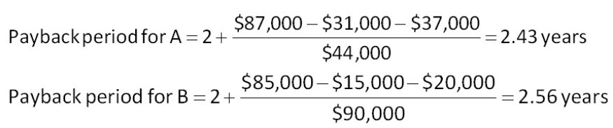

AACSB: Analytic
Bloom's: Analysis
Difficulty: Basic
Learning Objective: 9-2
Section: 9.2
Topic: Payback period
96. You are considering the following two mutually exclusive projects. Both projects will be depreciated using straight-line depreciation to a zero book value over the life of the project. Neither project has any salvage value.
Should you accept or reject these projects based on the profitability index?
A. accept Project A and reject Project B
B. reject Project A and accept Project B
C. accept both Projects A and B
D. reject both Projects A and B
E. You cannot make this decision based on the profitability index.
Because these are mutually exclusive projects, the PI rule should not be applied.

AACSB: Analytic
Bloom's: Analysis
Difficulty: Basic
Learning Objective: 9-7
Section: 9.6
Topic: Profitability index
97. You are considering the following two mutually exclusive projects. Both projects will be depreciated using straight-line depreciation to a zero book value over the life of the project. Neither project has any salvage value.
Should you accept or reject these projects based on the average accounting return?
A. accept Project A and reject Project B
B. reject Project A and accept Project B
C. accept both Projects A and B
D. reject both Projects A and B
E. You cannot make this decision based on the information provided.
The AAR cannot be computed because the net income was not provided.

AACSB: Analytic
Bloom's: Analysis
Difficulty: Basic
Learning Objective: 9-4
Section: 9.4
Topic: Average accounting return
98. Motor City Productions sells original automotive art on a prepaid basis as each piece is uniquely designed to the customer's specifications. For one project, the cash flows are estimated as follows. Based on the internal rate of return (IRR), should this project be accepted if the required return is 9 percent?
A. Accept the project.
B. Reject the project.
C. The IRR cannot be used to evaluate this type of project.
D. The firm should be indifferent to either accepting or rejecting this project.
E. Insufficient information is provided to make a decision based on IRR.
$5,500 – $5,900/(1 + IRR) = 0; IRR = 7.27 percent

AACSB: Analytic
Bloom's: Analysis
Difficulty: Intermediate
Learning Objective: 9-5
Section: 9.5
Topic: IRR and financing cash flows
99. Rosa's Designer Gowns creates exquisite gowns for special occasions on a prepaid basis only. The required return is 8 percent. Rosa has estimated the cash flows for one gown as follows. Should Rosa sell this gown at the price she is currently considering based on the estimated internal rate of return (IRR)?
A. Rosa should sell the gown for $155,000.
B. Rose can sell the gown for as little as $153,819 and still earn her required return.
C. The gown must be sold for a minimum price of $175,926 if Rosa is to earn her required return.
D. The IRR decision rule cannot be applied to this project.
E. Insufficient information is provided to make a decision based on IRR.
$165,000 – $190,000/(1 + IRR) = 0; IRR = 15.15 percent

AACSB: Analytic
Bloom's: Analysis
Difficulty: Intermediate
Learning Objective: 9-5
Section: 9.5
Topic: IRR and financing cash flows

Essay Questions
100. The profitability index (PI) of a project is 1.0. What do you know about the project's net present value (NPV) and its internal rate of return (IRR)?
If the PI is equal to 1.0, then the NPV = 0 and the IRR = Required return.

AACSB: Reflective thinking
Bloom's: Analysis
Difficulty: Basic
Learning Objective: 9-7
Section: 9.7
Topic: Profitability index
101. Explain how the internal rate of return (IRR) decision rule is applied to projects with financing type cash flows.
For financing type projects, the decision rule is reversed so that projects are accepted when the project's IRR is less than the required rate of return and rejected when the project's IRR is greater than the required return.

AACSB: Reflective thinking
Bloom's: Comprehension
Difficulty: Basic
Learning Objective: 9-5
Section: 9.5
Topic: Internal rate of return and financing cash flows
102. Explain the differences and similarities between net present value (NPV) and the profitability index.
The NPV and PI both consider the time value of money and result in the same accept or reject decision when considering an independent project. The main difference between the two is that the PI may be useful in determining which projects to accept if funds are limited; however, the PI may lead to incorrect decisions when considering mutually exclusive investments.

AACSB: Reflective thinking
Bloom's: Analysis
Difficulty: Basic
Learning Objective: 9-1 and 9-7
Section: 9.7
Topic: Profitability index and net present value
103. How does the net present value (NPV) decision rule relate to the primary goal of financial management, which is creating wealth for shareholders?
The NPV rule states that a project should be accepted if the NPV is positive and rejected if the NPV is negative. This aligns with the goal of creating wealth for a firm's shareholders as only projects which create wealth are approved for acceptance. Managers are indifferent to projects with zero NPVs, which is okay because such projects neither create nor destroy shareholder wealth.

AACSB: Reflective thinking
Bloom's: Analysis
Difficulty: Basic
Learning Objective: 9-1
Section: 9.1
Topic: Net present value

Multiple Choice Questions
104. An investment project provides cash flows of $1,190 per year for 10 years. If the initial cost is $8,000, what is the payback period?
A. 3.36 years
B. 5.28 years
C. 6.72 years
D. 8.13 years
E. never
Payback = $8,000/$1,190 = 6.72 years

AACSB: Analytic
Bloom's: Application
Difficulty: Basic
Learning Objective: 9-2
Section: 9.2
Topic: Payback
105. An investment project costs $21,500 and has annual cash flows of $4,200 for 6 years. If the discount rate is 20 percent, what is the discounted payback period?
A. 4.41 years
B. 4.67 years
C. 5.12 years
D. 5.40 years
E. never
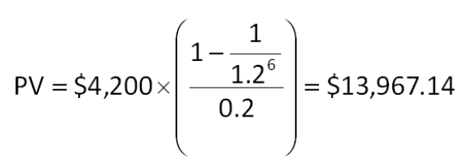

AACSB: Analytic
Bloom's: Application
Difficulty: Basic
Learning Objective: 9-3
Section: 9.3
Topic: Discounted payback
106. You're trying to determine whether to expand your business by building a new manufacturing plant. The plant has an installation cost of $12 million, which will be depreciated straight-line to zero over its 4-year life. The plant has projected net income of $1,095,000, $902,000, $1,412,000, and $1,724,000 over these 4 years. What is the average accounting return?
A. 10.70 percent
B. 15.63 percent
C. 18.87 percent
D. 21.39 percent
E. 23.05 percent

AACSB: Analytic
Bloom's: Application
Difficulty: Basic
Learning Objective: 9-4
Section: 9.4
Topic: Average accounting return
107. A firm evaluates all of its projects by applying the IRR rule. The required return for the following project is 21 percent. The IRR is _____ percent and the firm should ______ the project.
A. 23.67 percent; reject
B. 24.26 percent; accept
C. 24.26 percent; reject
D. 26.30 percent; accept
E. 26.30 percent; reject
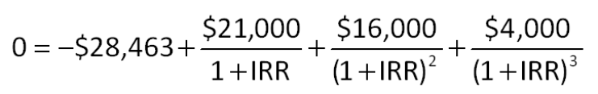

AACSB: Analytic
Bloom's: Application
Difficulty: Basic
Learning Objective: 9-5
Section: 9.5
Topic: Internal rate of return
108. A firm evaluates all of its projects by using the NPV decision rule. At a required return of 14 percent, the NPV for the following project is _____ and the firm should _____ the project.
A. $5,684.22; reject
B. $7,264.95; accept
C. $7,264.95; reject
D. $9,616.93; accept
E. $9,616.93; reject
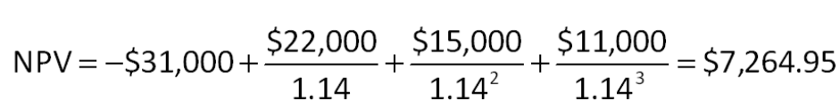

AACSB: Analytic
Bloom's: Application
Difficulty: Basic
Learning Objective: 9-1
Section: 9.1
Topic: Net present value
109. A project that provides annual cash flows of $12,600 for 12 years costs $67,150 today. At what rate would you be indifferent between accepting the project and rejecting it?
A. 15.28 percent
B. 15.40 percent
C. 15.51 percent
D. 15.62 percent
E. 15.74 percent
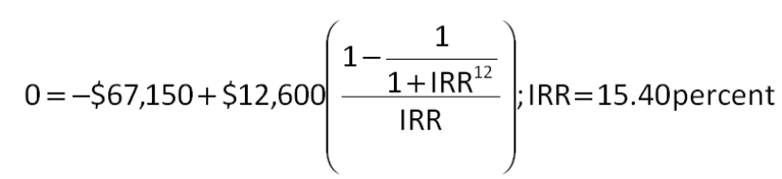

AACSB: Analytic
Bloom's: Analysis
Difficulty: Basic
Learning Objective: 9-5
Section: 9.5
Topic: Internal rate of return
110. Hungry Hoagie's has identified the following two mutually exclusive projects:
At what rate would you be indifferent between these two projects?
A. 17.34 percent
B. 17.72 percent
C. 19.41 percent
D. 19.69 percent
E. 20.28 percent
The crossover rate is the IRR of the differences between two sets of cash flows.

AACSB: Analytic
Bloom's: Analysis
Difficulty: Basic
Learning Objective: 9-5
Section: 9.5
Topic: Crossover rate
111. Consider the following two mutually exclusive projects:
What is the crossover rate for these two projects?
A. 6.29 percent
B. 6.48 percent
C. 6.71 percent
D. 6.75 percent
E. 6.94 percent
The crossover rate is the IRR of the differences between two sets of cash flows.

AACSB: Analytic
Bloom's: Application
Difficulty: Basic
Learning Objective: 9-5
Section: 9.5
Topic: Crossover rate
112. The relevant discount rate for the following set of cash flows is 14 percent. What is the profitability index?
A. 0.89
B. 0.93
C. 0.99
D. 1.03
E. 1.07
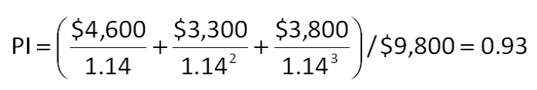

AACSB: Analytic
Bloom's: Application
Difficulty: Basic
Learning Objective: 9-7
Section: 9.6
Topic: Profitability index
113. Consider the following two mutually exclusive projects:
The required return is 15 percent for both projects. Which one of the following statements related to these projects is correct?
A. Because both the IRR and the PI imply accepting Project B, that project should be accepted.
B. The profitability rule implies accepting Project A.
C. The IRR decision rule should be used as the basis for selecting the project in this situation.
D. Only NPV implies accepting Project A.
E. NPV, IRR, and PI all imply accepting Project A.
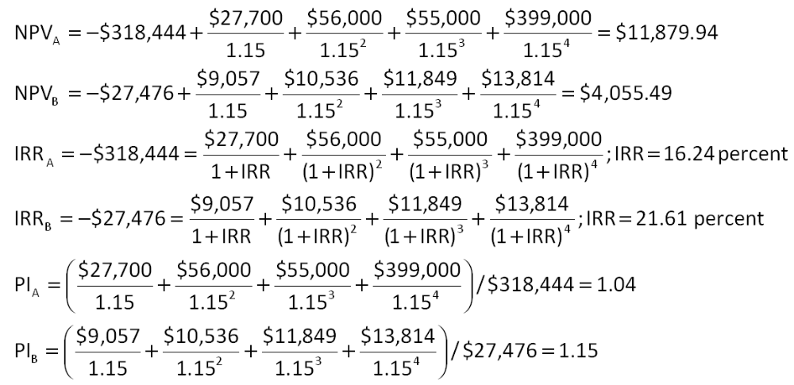

AACSB: Analytic
Bloom's: Analysis
Difficulty: Basic
Learning Objective: 9-1
Learning Objective: 9-5
Learning Objective: 9-7
Section: 9.1, 9.5 and 9.6
Topic: Decision rules
114. An investment project has an installed cost of $518,297. The cash flows over the 4-year life of the investment are projected to be $287,636, $203,496, $103,802, and $92,556, respectively. What is the NPV of this project if the discount rate is zero percent?
A. $47,306
B. $72,418
C. $91,110
D. $128,415
E. $169,193
NPV = -$518,297 + $287,636 + $203,496 + $103,802 + $92,556 = $169,193

AACSB: Analytic
Bloom's: Analysis
Difficulty: Basic
Learning Objective: 9-1
Section: 9.1
Topic: Net present value
115. The Taxi Co. is evaluating a project with the following cash flows:
The company uses a 10 percent interest rate on all of its projects. What is the MIRR using the discounted approach?
A. 13.25 percent
B. 14.08 percent
C. 16.40 percent
D. 17.17 percent
E. 19.23 percent
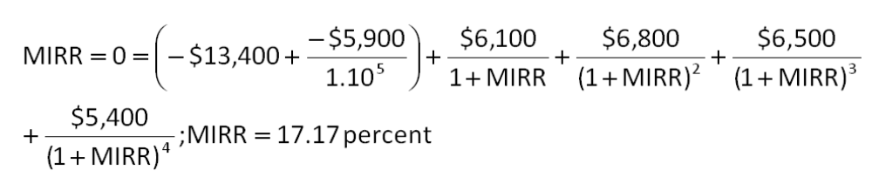

AACSB: Analytic
Bloom's: Application
Difficulty: Basic
Learning Objective: 9-6
Section: 9.5
Topic: Modified internal rate of return
116. The Chandler Group wants to set up a private cemetery business. According to the CFO, Barry M. Deep, business is "looking up". As a result, the cemetery project will provide a net cash inflow of $57,000 for the firm during the first year, and the cash flows are projected to grow at a rate of 7 percent per year forever. The project requires an initial investment of $759,000. The firm requires a 14 percent return on such undertakings. The company is somewhat unsure about the assumption of a 7 percent growth rate in its cash flows. At what constant rate of growth would the company just break even?
A. 4.48 percent
B. 5.29 percent
C. 5.61 percent
D. 6.49 percent
E. 6.75 percent
The minimum growth rate is the IRR as that is the rate that produces a zero NPV.

AACSB: Analytic
Bloom's: Analysis
Difficulty: Challenge
Learning Objective: 9-5
Section: 9.5
Topic: Internal rate of return

